**Learning Aim A: Understand the principles of website development**

**Purpose of websites**

There are many purposes of creating websites, the first one would be for awareness as maybe you’re making a website for a new brand, blogging posts, or for a particular topic you want to share online. Another reason would be for sales and conversion for business websites that are selling products or services, finally to simply share information for example Wikipedia.

Besides providing information, websites feature functionality that enables users to complete tasks, such as searching the site, submitting an online form, or using interactive design features.

**Two websites**

The two websites I have chosen to compare and evaluate are Home Bargains, <https://home.bargains/> and B&M https://www.bmstores.co.uk/ . I will be examining these 2 websites side by side looking at each in detail, for example looking into the layout of the websites, colour scheme, font size and type, their accessibility and overall feedback from other users.

What’s the difference between these 2 websites? Well Home Bargains is known for its “ Star buys” which are labelled as such with a big yellow label alerting you that they are on offer, meanwhile B&M label “ Reductions “ on price labels in store at on their website After reviewing these 2 websites taking in the positive and negatives, I am going to create a website for a client using the knowledge and information that I have gathered from studying these two websites and adapting what I liked to my website and adding other features.

**Home Bargains**

In August 2011, Home bargains opened a website to enable customers shop with them online. Home bargains is a stand-alone retailer with a stand-out philosophy. With a unique independent approach, they combine the prices of a discount retailer with well-designed quality stores and fresh, friendly service. The result? A luxury shopping experience with a budget price tag.

They have created a online website that users can place orders on and receive their items straight to their door, users can also scope the site to see if products are available in their local store. Its on of the UK’s fasters growing discount retailers. They are considerably the UK’s leading variety goods value retailer, providing customers with a limited assortment of the best-selling teams across a range of grocery and General Merchandise categories, all at value prices, around 30% of the range comprises clearances lines, they are so popular as they take advantage of consumer trends towards value and convenience.

Their website takes Visa, Master card, apple pay and google pay. Many users many do not know this but their site is protected by the PCI, security standers council, Level 1 DDS certified merchant.

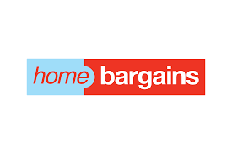

**B&M**

B&M is a retailer of consumer goods. The company offers a range of grocery and non-grocery products. Its product portfolio includes toiletries, household goods, food and drink, furniture, baby care, health and beauty, electrical, toys and games, pet care, and home adornment. This website allows users to browse and see if their local store has products in stock, they don’t offer delivery unlike home bargains.

I enjoyed many features within the website and some even I will incorporate into my own, but this website includes many pictures in galleries of products they sell also include a dropdown list of different categories of the website like “Home” and “fashion”. They also give the offer to their users to look at their social media pages, newsletters, brands and the opportunity for users to look at careers in this industry.

 Their site is security protected so their user’s information is safe and secured to make sure nobody gets a hold of it. They have an apple which is available on the apple store and google play.

**Home Bargains**

* **Target Audience**

Home Bargains online store and shop target people looking for food, utilities, toys and many more but for cheaper. They sell remarkably similar stock to B&M making them a competitor. Their target audience has a very wide range but mostly people who are looking for a cheaper alternative for products or people just shopping about for novelty items.

This is the type of shop that people go in for a few things and exit with more than a trolly full, so therefore their target audience reaches anyone who Is able to enter their store looking for a cheaper alternate and buy items like these.

* **Type of website**

You can browse the website before you enter the store, to check for availability of a certain product and check their prices of certain items to, users are also able to view their social media, newsletter and users can leave questions or queries.

They can also place orders and get them directly delivered to your front door within 2 or 3 days to their address, which is stored safety within their website and protected from people viewing it. Its eCommerce net sales are generated entirely in the United Kingdom.

* **Purpose of website**

The purpose of the Home Bargains website is for users to interact with their site as its web 2.0 and browse through it for certain products they may need and simple move it to their basket and being able to get it shipped to their door in 2 to 3 days. Users are also able to add their own opinions with leaving reviews and ratings on products they like, or dislike and they can also contact or leave questions or quires for the team working behind the website.

This website also offers users to check their social media, for example Facebook, twitter and Instagram. Users can leave comments on their posts about new products and updates on their stock, they also can like and share the post to other, this is benefiting the home Bargains social media by making a larger base and reaching out to more users.

* **Website layout**

The Home Bargains website consists of a banner which is a dark blue colour throughout, included within their banner they have their logo centred in the left, and centred on the right is 3 different features, one where users can sign in to an existing account, the next one helps users find their local stores and the last one is a basket where users can click to view all of the item they have chosen. Each one of these features has a icon above relating to it, e.g. above the text which reads basket has a image of a shopping basket.

Below this they have inserted a search bar and a horizontal and vertical list of categories, the vertical list when click drops down to let users view more categorises in detail for example, the top list includes heads as easter and homeware then within the dropdown list you have bedding and flowers. Below they have 4 x 8 grid of images containing products and titles of categories, users are able to left click these images to be taken to a different page containing these items. Under is a horizontal list of their weekly trending products and other departments. Finally their footer is the same colour as their banner it contains information like their social medial, customer service, policy and their about us.

* **User friendly**

The Home Bargains websites has taken into the consideration of being user friendly to people who maybe have a hard time reading, looking at images or just even understand certain words. I believe that the colour scheme they have designed for the site is practical choice as its not hurtful to the eye, not to bright and its not to dull where people may not be able to see the writing with the dull colour, the background is mostly while and a shade of dark blue. The text font, colour and size was a good choice as I feel its very easily read, and overall the site is layout quite well, with it mostly being images, I believe this could help any users who maybe cant read as well as other and the images will help them see products.

The whole website is designed simple and not to complicated, the only thing I think could improve is the dropdown list, it includes lots of subheadings which may be confusing and as there is so many the font size has decreased to fit more in which can be an issue for people with bad vision.

* **Consistency**

I believe that the home bargain website is very consistent. Every page that you open shares the same colour scheme, font size and colour and a similar layout on each page.

I think that having a consistent website makes it look simple but modern at the same time, just in the middle.

This consent approach makes the website more engaging and draws attention to users, this layout can also be helpful as it will be familiar to users, increasing the activity on the site and creating a more user-friendly atmosphere.



**B&M**

* **Target Audience**

B & M holds remarkably similar types of products that Home Bargains may have, making their target audiences extremely identical as they also try to bring in the socio-economic group of people towards their stores. Their target audience has a very wide range but mostly people who are looking for a cheaper alternative for products, B&M is more know for not having special offers but for their reductions from items.

Many will compare prices and sometimes users can find that the same item in home bargains is on a reduction in B&M for that bit cheaper. They both attract people who are looking for well designed items but are just cheaper.

* **Type of website**

The B&M website is slightly different than the home Bargains site. You are still able to check availability for a product and it’s still an eCommerce website, so they also have their social media platform, but they do have other features that home bargains doesn’t have a newsletter and videos and images inside the store. This website has a feature where if users click onto their lifestyle page, they can find blogs, videos, 360* rooms, inspire me, how to guides and recipes. These can come in useful to users as the posts are updated every so often and users can relate to certain aspects as it’s a lifestyle page.

Other than that user may browse the site for items and check prices but B&M doesn’t offer delivery so people will have to find their nearest store.

* **Purpose of website**

The purpose of the B&M website is useful to users if they are unsure of any information on a product, maybe they want to check how much an item could be or how big or small another item can be, users can browse around and search for certain items, the website also displays the product code of an item which can be helpful for users and the site also gives a detailed product description and a return policy.

Unlike the Home Bargains website, the B&M site has many more social media plat forms than they have included in their site. Users can log onto to Facebook, TikTok, twitter, YouTube, linkden and many more! Users can leave comments on posts or reviews of products to inform other users of anything positive or negative about it which Is helpful.

* **Website layout**

The B&M website consist a small horizontal add across the top of their site, current the adds reads “ UP TO 40% OFF SALE SALE SALE UP TO 40% OFF” with a red background and white bubble writing, these adds change every so often to keep up with the new offers, Underneath is their banner which includes their logo centred on the far left and a menu icon beside this, on the right hand side is features like deals, trending, social, stores, offers and mangers special these all include a small icon above them symbolising what their functions are. If users left, click these icons they will be redirected to that page.

Below this is a search bar and underneath is a drop down list of all the different categories, when clicked the text and the corelating image appears above this in, and then it continues down to images of items and new sales productions and more adds of their own. Finally, their footer includes their About us, Lifestyle, Social, Charity, company information and a help centre where users can find out more information on return policy, terms of use and their privacy policy.

* **User Friendly**

This website can be viewed as user friendly; most headings are laid out in an organised format but unlike the home bargains site, they use a very light-coloured font and a small font size that can be hard to see to users who have bad eyesight or they possible could be colour blind and light colours can just make it worse.

Also, the whole website itself could be spaced out a little more as users may get confused on where to locate a product as images are placed awfully close tother and some letting may be too small and squished for users to read.

* **Consistency**

The B&M website has aspects of consistency as the banner does not change when you search for products, but if you click headings for example their newsletter, it changes colour from blue to orange. This may be just because the B&M logo is two assorted colours (Blue and orange) and they just wanted to incorporate both themes.

The site has a consistent amount of white spacing along the sides throughout which is important in any website. This consent approach makes the website more engaging and draws attention to users, this layout can also be helpful as it will be familiar to users, increasing the activity on the site and creating a more user-friendly atmosphere.



**Home Bargains**

* **Usability**

The home Bargains website is very easy to use in my opinion as any text you can see has an appropriate font size and colour, also text is very simple to understand for users who many have problems viewing or reading text. The home page contains lots of pictures of products it can be overwhelming to some users but when click it will take you to that product and give more information on that item. This site also works on google chrome, yahoo, Microsoft edge, Safari (for mobile) and any other web page platform.

* **White space**

The Home Bargains website does not use a lot of white space so it can seem a bit messy, but it’s used effetely between the different department’s titles creating enough space between them so it’s not mixing images or text together. There is a consistent use of white spacing of the left and right side of the site going all the way from top to bottom vertically. White spacing is very import to have on a webpage as its used to balance the pages design, organize the content and elements and improve the visual experience for the user.

* **Site layout**

The Home Bargains website has great site layout as they have their header which contains their banner, logo, login feature, searching for your local store feature, shopping basket feature, and search bar consistently on each page, they have also been positioned in an appropriate layout across the banner. The overall layout is perfect and not complicated, as navigation links, text and graphics are positioned efficiently on the website which makes it user-friendly and has a clear navigation for anyone to use.

* **Accessibility**

The accessibly of their website ensures equal access to everyone to information, elements as the text size, colour and position takes that barrier away that would prevent a person with a disability or poor vision using the site. Web accessibility ensures that all visitors, regardless of ability, have a seamless experience on a website. Unfortunately, many sites don’t comply with web accessibility best practices and guidelines which makes is difficult for users with disabilities. Fortunately the Home bargains website makes sure that all users can accurately see and read the websites content and they also made sure that its simple to navigate for all users.

* **Navigation**

The Home Bargains website makes sure users can navigate their way easily around the site, even if they are a new user to this particular website, buttons and links are made obvious and easily accessible, one way they have adapted this principle is by inserting a drop-down list containing all the departments and categories. This is consistent across the whole website and there is an intuitive structure of pages.

* **Typography**

The Home Bargains website uses the font ‘open sans’ the most with products and headings, it’s a big enough font size that can be easily understood by users who aren’t familiar with this website, and it also makes the text clear and legible to all users, even visitors who have a hard time reading or viewing text, they have made sure that its simple enough to read. This font has no embellishments applied to the letters making them clearer and easier to read and understand.

* **Alignment**

The Home Bargains website uses diverse types of alignment, as some pictures of items will have text beside it or under it depending on where the other images are, and these will be separate with small line of white spacing this is what makes the site look put together and neat. The alignment changes through out the website as the first section all the images are in a grid all in the same line with the same amount of white spacing between them, under this you have another section with images that could be bigger than some creating more white space than others and so these images are not align. Overall, this website does a great job with alignment.

* **Clarity**

The Home Bargains website is designed to be clear with all its users. They have chosen a design which is simple and clear, for example if you would like to find stores around you, there is an available map to use which you can enter your post code and It will show you many different shops around your location, this can be very helpful to users who are unsure of the shop locations nearest to them. Another reason on how the website is clear with its users is how they have put all their social media links in their footer, this gives their users easy access to view their Facebook or twitter. All information gets right to the point whether it be the price of a item or a short description.

* **Consistency**

This website is consistent in many factors as ever page has the same fonts, design and the yellow/dark blue/white colour scheme is seen on every page, this design is consistent, and users will find it easier to navigate around as all the web pages are consistent with one another. This particular web site has different sections for their new products and a section that changes every season/event. This makes it simpler for uses to navigate around, so they’re not searching for a item that maybe new or just in for a certain holiday/event. Overall consistency ensures that this website looks coherent and works harmoniously across all its different elements, such as headers, footers, sidebars and navigation bars. It also gives their users a more positive experience, enables users to carry out tasks more quickly and efficiently.

* **Accuracy**

Accuracy refers to whether a website provides verifiable and reliable information. I have reviewed and researched the Home Bargains website and found out that the site is updated often and its accurate as there are new deals and offers every few weeks that needs to be uploaded on the website with their correct pricing. They have recently updated their home page from Halloween products to Christmas items. There cant be any mistakes on any of their items or adds as this is classified as “ false advertising”

* **Content**

The Home Bargains website consists of lots of content that is all their own products and all their own pictures. It is all consistent in style on each page and there is text under each product which is also consistent on each page. The content on their website needs to be accurate and up to date. If a visitor discovers incorrect or old information on their site, they are likely to lose confidence in the company and will quickly bounce to another site. Lucky this is not going to happy for this website as its checked daily.

* **Media and objects**

The home bargains websites include a drop-down list and an interactive image marque for their users. By presenting information visually and textually, media objects help to make content more engaging and easier to understand. This particular site has sliding images that displays products, visitors can understand how move from one item to another, as it’s a simple design, a left and right click button. This site is kept tidy and clean as to many elements of media and objects can create a messy look and even put users off from visiting sites.

* **Simplicity**

The Home Bargains website in my opinion is slightly on the simple side but also they use multimedia, the simple design of the site creates an appealing atmosphere,

**B&M**

* **Usability**

The B&M website is an ok website to use in as the text size is a bit on the small size, even for the headings also the colour of some of the text is a light grey on a white background which is hard for users to see. This site also works on google chrome, yahoo, Microsoft edge, Safari (for mobile) and any other web page platform. There isn’t as many images on this web site as the Home Bargains site which makes it a bit more simple.

* **White space**

The B&M website uses much more white space than the HB site. As they have different categories and pictures that have been separated by a good amount of white space, so it’s not confusing or overwhelming to others. They also have white space down the sides which makes it cleaner.

* **Site layout**

The B&M website has an overall good site layout as their header with their different categories stays in the same position throughout the website, elements like pictures are positioned perfectly, other elements as text may change size and fonts on different pages which can be confusing and default to read. Overall, it has a clear navigation path and its user friendly.

* **Accessibility**

The accessibility of this website isn’t as good when compared to the HB site as text is a little smaller and not a great colour and very little text is ither highlighted or a different colour which gives the site a very dull look. On the other hand the pictures are large and easy to see and click on, and its easy enough to navigate around but it could 100% use some updates their colour scheme and their font.

* **Navigation**

The B&M website has aspects of good navigation as there is also a drop-down list containing pictures as well as text. Overall they have made it obvious across all pages how to navigate between sections and isn’t confusing to users.

* **Typography**

The B&M website uses the font ‘Oxygen’ with products and headings, the font could be a little bigger with most of the subheadings as people who might has poor vision or difficulty reading will struggle a bit with these but is still legible to some users. The text under products giving a detailed production description has a great font size and colour, if this were applied to the rest of the site it would have made it more user friendly. This font has no embellishments applied to the letters making them suitable to selected users.

* **Alignment**

Alignment is an important concept and serves as one of the principles of graphic design. The B&M website uses alignment throughout their site to show where elements end and where they start. For example when users first open the page they are greeted with an assortment of images in a suitable aliment that is neat and makes the website look clean and simple, just buy having things in a certain alignment can change so much about a website, if everything is neat and align users will be able to scan the site fast and they will be able to stop looking when they have found the item they wanted, users wouldn’t be able to complete this if the website was cramped and not in a certain alignment. Overall I think that the B&M website had a good design plan for the alignment of elements as all images are level with one another and text has the same length apart from a image on every page.

* **Clarity**

The B&M website has been created with a good design plan and it’s also clear with communicating with users. They have chosen a design which is simple and clear, for example if you would like to find stores around you, there is an available map to use which you can enter your post code and It will show you many different shops around your location, this can be very helpful to users who are unsure of the shop locations nearest to them. Another reason on how the website is clear with its users is how they have put all their social media links in their footer, this gives their users easy access to view their Facebook or twitter. All information gets right to the point whether it be the price of a item or a short description.

* **Consistency**

The B&M website is consistent in their colour scheme of orange/blue, which matches their logo colours, they keep this consistent through out the site. They keep their font the same colour for product descriptions and the cost of the item, this writing it under neath the picture of them, this is the exact same for each item that Is shown on the B&M website so they have kept this consistent. The website is also consistent with their white spacing along the left and right of the webpage giving it a clean look throughout. . Overall consistency ensures that this website looks coherent and works harmoniously across all its different elements, such as headers, footers, sidebars and navigation bars. It also gives their users a more positive experience, enables users to carry out tasks more quickly and efficiently.

* **Accuracy**

Accuracy refers to whether a website provides verifiable and reliable information. I have reviewed and researched the B&M website and discovered that every so often they will get new products in their store which they need to update online so users can be known of these items, for visitors to be able to know if their store has this item the website has to be updated weekly or even daily as prices could change at any time and they have to be correct for users. Currently we are leaving the month of October, Halloween decorations are coming down and so is the stocks in stores, very soon the front page of the website will contain images of Christmas stock that will need to be uploaded onto the side for it to be accurate to users.

* **Content**

The B&M website consists of lots of content that is all their own products and all their own pictures. It is all consistent in style on each page and there is text under each product which is also consistent on each page. The content on their website needs to be accurate and up to date. If a visitor discovers incorrect or old information on their site, they are likely to lose confidence in the company and will quickly bounce to another site. Lucky this is not going to happy for this website as its checked daily.

* **Media and objects**

The B&M websites include a drop-down list and an interactive image marque for their users, they are very similar to the features in the Home Bargains Website. By presenting information visually and textually, media objects help to make content more engaging and easier to understand. The very first thing users will see when they enter the sight is a sliding photo gallery that atomically slides images across every few seconds. Fortunately there is not a overload of media on the site, this makes sure the website doesn’t slow down for visitors and the website is kept tidy and clean. To many elements of media put some users off and the website can be seen as messy and full of clutter.

* **Simplicity**

The B&M website has gone for a very basic design and basic colours, making this website simpler than the home bargains website as there is more elements on the home page which make it more vibrant, unlike B&M. A website being designed like so can have many benefits, it won’t be difficult to news users who have never visited the site before, they will know how to move around the web page without getting confused. This page has managed to combine content they need to get across with a clear and simple, easy-to-use design that attracts users back because they know they will get what they need from the site without a fuss. They have done a good job on not overcomplicating their designs.



**Bibliography**

[**https://www.bmstores.co.uk/**](https://www.bmstores.co.uk/)

[**https://home.bargains/**](https://home.bargains/)

[**https://duck.school/en**](https://duck.school/en)

[**https://www.dropbox.com/**](https://www.dropbox.com/)

[**https://webflow.com/**](https://webflow.com/)

[**https://girlboss.com/**](https://girlboss.com/)

[**https://www.awwwards.com/**](https://www.awwwards.com/)

[**https://www.google.co.uk/**](https://www.google.co.uk/)

[**https://www.tesco.com/**](https://www.tesco.com/)

[**https://www.behance.net/**](https://www.behance.net/)

[**https://nicepage.com/**](https://nicepage.com/)

[**https://www.smashingmagazine.com**](https://www.smashingmagazine.com)

**Content Based 2.0**

Users can interact with this website by using the dropdown list to view more products

Users can create and sign into an account with their information

Users can access a map to use to find a store close to them

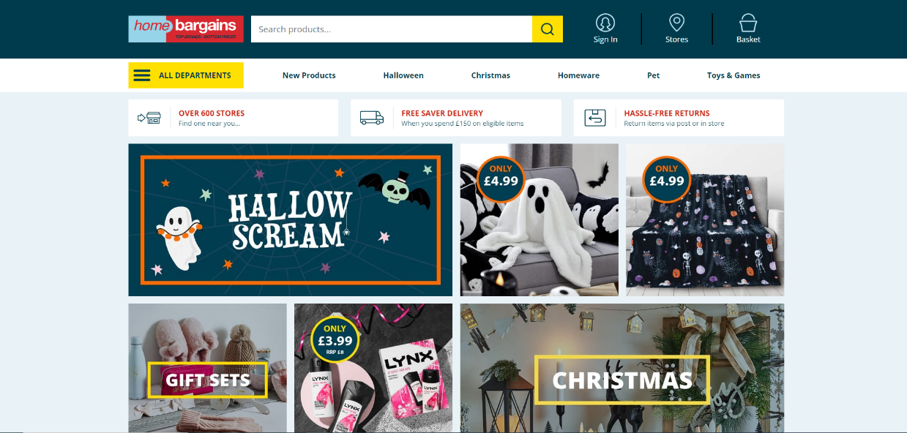

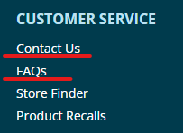Web 2.0 describes the current state of the internet, which has more user-generated content and usability for end-users compared to its earlier incarnation, Web 1.0. The home Bargains website is an example of web 2.0 as it is a Dynamic website, information and content is always changing about their products.

This website also offers costumer service help for any queries or questions.

Users can see what department or section of the site they have clicked on to, this also enables them to easily go back to a pervious section.

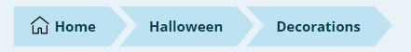

Users can see special offers here as the slide show changes every few days with new offers

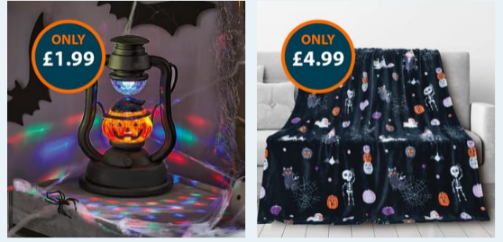

This site uses web 2.0 very often as they have pictures of different products that changes every week.

People can find word wide stores by searching here.

The B&M website allows costumers to use a dropdown list, to view different departments

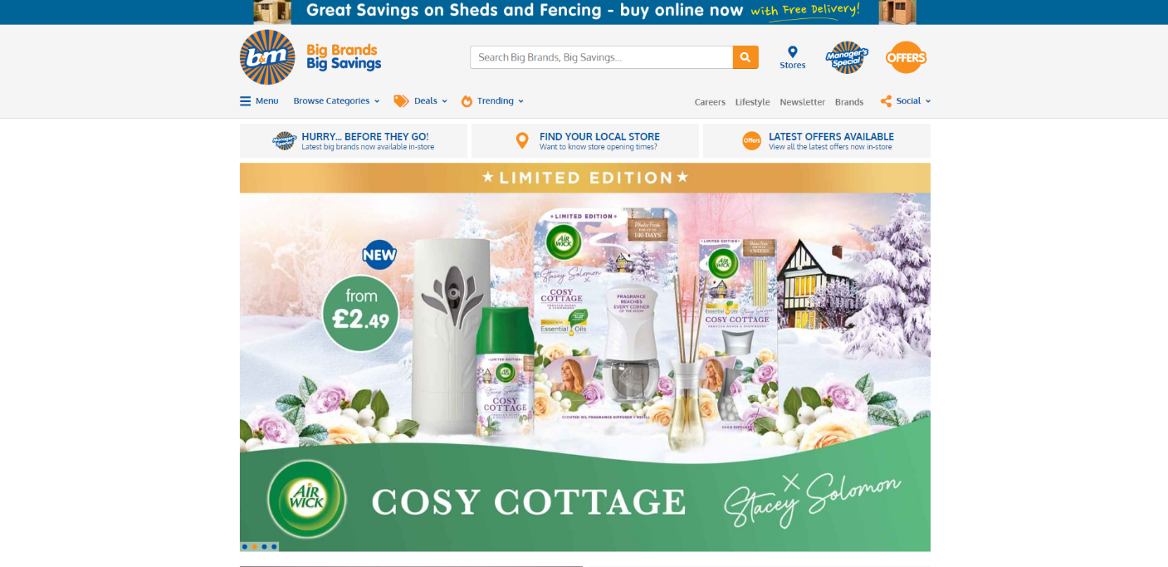

Users can search for available stores near to their home.

Users can follow their social media e.g twitter and Facebook, to see information and updates.

**Learning Aim B: Design a website to meet client requirements.**

**Problem definition statement requirements**

For me to be able to create a website I needed to gain information, so I had a professional meeting with my client, the CEO of Hot Beans Web who asked me to develop a 5-page website under his own requirements, that meant having a colour scheme of brown and white and have features of web 2.0.

**Intended audience.**

Within the meeting with the CEO of Hot Beans Home (Roberto) he made sure that I was aware of the intended audience he wanted me to reach. The website targets people who are looking for trainee courses or qualifications related to web development and users interested in having a job as a web developer where they can apply on the website.

**A full summary of the problem to be solved.**

In my brief meeting with the CEO of Hot Beas Web, Roberto gave me detailed information on how he wanted his website to designed and how it would function. From the survey I received I understand I had to make a 5 paged website that consisted of a home page, Job vacancies page, our team page, contact us page and a Courses page that has different links to access courses. It also must have a brown, white colour scheme, and contact details in the footer and their social media links.

**Constraints**

Roberto, the CEO of Hot Beans Web made me knowledgeable of the constraints he set for the website. The cost was one of them as he gave me a budget of £700 and 2 months to complete it. Roberto allowed me to get staff to help build the website, so I had to accept staff training to make sure their employees are able upload information to the website.

**Benefits**

One of the reason the CEO of Hot Beans Web approached, as website developer I can provide many benefits that a website will bring to their business. The website will be more accessible its available 24/7 to any user and customers will not be turned away because of this. Another benefit of a website is that it can give you an online advantage, build trust, and boost your brand credibility.

**Nature of interactivity**

Withing the meeting I had with the CEO of Hot Beans Web, we discussed how he wanted the website to include a few interactive features, so I have inserted features like google maps, hyperlinked images and text.

**Complexity**

During the meeting with the CEO of hot Beans Web we discussed that a website that is properly built is easy to navigate around for users, has a useful layout, relevant information, responsive design and well designed and functional.

**Requirements**

Client Requirements

Roberto had asked me to create a new section of the website they consist of a home page, Job vacancies page, our team page, contact us page and a Courses page.

User requirements

**Mood board**

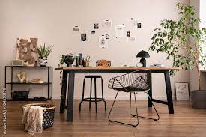

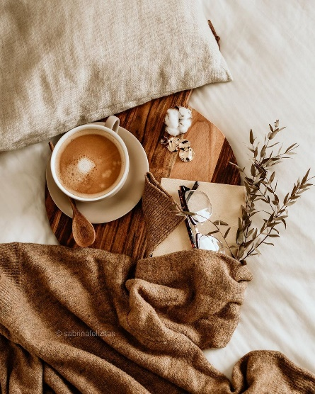



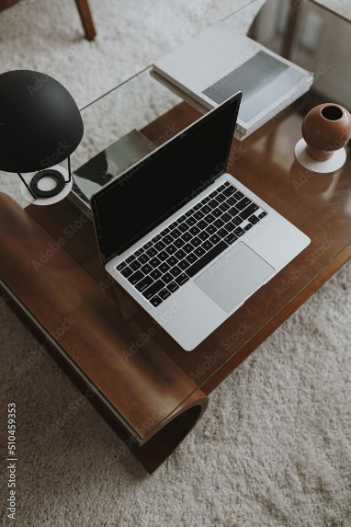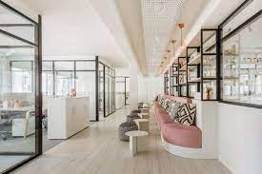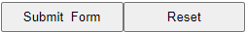******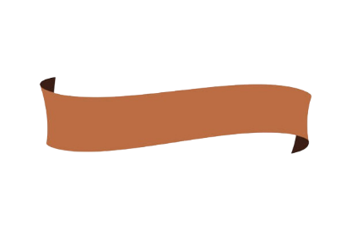**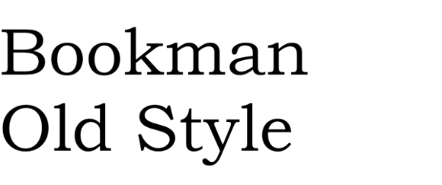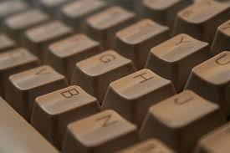

MOVIE

**Feedback from mood board**

I had a meeting with my client to discuss a design plan for the website, I felt it would benefit if I created a mood board for my client to review and go over what he felt what would work with the site and what wouldn’t work. I created this mood board while focusing on the colour brown and all the colours that can relate to it, my client was pleased with the colour scheme I had chosen, and he also liked all the different shades of brown and beige I used to give the website a warm feel. Roberto, the CEO wanted me to incorporate interactive features to the website so I suggested having buttons with the application form and inserting a picture gallery where users can go back and forth with the images.

I suggested 2 different types of colour schemes Roberto could chose from, in the end my client didn’t like the green/blue colours as he felt that it would make the website look unappealing and not give it that cosy, warm and comforting effect. Brown also blends well with most colour like white and beige so he thought it would give the website a more natural look. Roberto saw the green/blue colour scheme as to vibrant for this type of site as he wanted something more monotone, this wouldn’t work with the green or blue as they are very harsh colours.

**Storyboarding**

www.google.com

**Index**

Contact us page link HTML

www.reed.co.uk

www.reed.co.uk

www.codeacadmeny.com

Email link @

www.instagram.com

www.twitter.com

www.facebook.com

Job Vacancies

Contact Us

Our Team

Courses

|  |
| --- |
| **Banner Image: Banner copy 1 Width:** 100% **Hight:** 300px **Alt:** Hot Beans Web Banner **src:** Pictures/Banner%20copy%201.jpg  Created on Adobe Photoshop |

|  |  |  |  |  |  |
| --- | --- | --- | --- | --- | --- |
| **Text:** Home  **Font:** Lucida sans  **Font size:** Large  **Font colour:**  #000000  **Hight:** 10px  **Width:** 360px  **BG colour:**  #EED1BB  **Aliment:** Centre | **Text:** About Us  **Font:** Lucida sans  **Font size:** Large  **Font colour:**  #000000  **Hight:** 10px  **Width:** 360px  **BG colour:**  #EED1BB  **Aliment:** Centre | **Text:** Courses  **Font:** Lucida sans  **Font size:** Large  **Font colour:**  #000000  **Hight:** 10px  **Width:** 360px  **BG colour:**  #EED1BB  **Aliment:** Centre | **Text:** Job Vacancies  **Font:** Lucida sans  **Font size:** Large  **Font colour:**  #000000  **Hight:** 10px  **Width:** 360px  **BG colour:**  #EED1BB  **Aliment:** Centre  **Insert Marquee** <MARQUEE bgcolor="#A58D7C" direction="right" loop="20" width="100%" class="auto-style14"><STRONG>Greetings, Welcome to Hot Beans Web.</STRONG></MARQUEE> | **Text:** Our Team  **Font:** Lucida sans  **Font size:** Large  **Font colour:**  #000000  **Hight:** 10px  **Width:** 360px  **BG colour:**  #EED1BB  **Aliment:** Centre | **Text:** Contact Us  **Font:** Lucida sans  **Font size:** Large  **Font colour:**  #000000  **Hight:** 10px  **Width:** 360px  **BG colour:**  #EED1BB  **Aliment:** Centre |

|  |  |  |  |  |
| --- | --- | --- | --- | --- |
| **Hight:** 46px  **Width:** 285px  **BG colour:** #A58D7C | **Text:** Address  **Font:**  Lucida sans **Hight:** 46px  **Width:** 285px | **Text:** Contact us by: **Font:** Lucida sans **Hight:** 46px  **Width:** 285px | **Text:** Follow us on **Font:** Lucida sans **Hight:** 46px  **Width:** 285px | **Text:** Get help **Font:** Lucida sans **Hight:** 46px  **Width:** 285px |
| **Hight:** 115px  **Width:** 189px  **BG Colour:**  #A58D7C  **Image:**  Pictures/  Women.jpeg  **Alt:** Working  **Src:**  Pictures/  Women.jpeg | **Hight:** 46px  **Width:** 285px  **BG colour:** #EED1BB | **Text:** Email… **Font:** Lucida sans **Hight:** 46px  **Width:** 409px | **Text:** Twitter…. **Font:** Lucida sans **Hight:** 46px  **Width:** 409px | **Hight:** 46px  **Width:** 285px  **BG colour:** #EED1BB |
| **Text:** Main building… **Font:** Lucida sans **Hight:** 46px  **Width:** 285px | **Text:** Phone number… **Font:** Lucida sans **Hight:** 46px  **Width:** 285px | **Hyperlinks** | **Text:** If you have… **Font:** Lucida sans **Hight:** 46px  **Width:** 253px |
| **Hight:** 46px  **Width:** 285px  **BG colour:** #EED1BB | **Hight:** 46px  **Width:** 285px  **BG colour:** #EED1BB | **Hight:** 46px  **Width:** 285px  **BG colour:** #EED1BB | **Hight:** 46px  **Width:** 285px  **BG colour:** #EED1BB |
| **Hight:** 46px  **Width:** 285px  **BG colour:** #A58D7C | **Text:** Enter email… **Font:** Lucida sans **Hight:** 46px **BG colour:** #A58D7C  **Width:** 285px | | | **Hight:** 46px  **Width:** 285px  **BG colour:** #A58D7C |

**Wireframe **

Image: Pictures/F 4.png **Alt:** Icon **Hight:** 40px **Width:** 64px **Location:** <https://en-gb.facebook.com>

Image: Pictures/X.png **Alt:** Icon **Hight:** 40px **Width:** 64px **Location:** [**https://twitter.com/**](https://twitter.com/)

Image: Pictures/InstagrаmLogo.png **Alt:** Icon **Hight:** 40px **Width:** 64px **Location:** [**https://www.instagram.com/**](https://www.instagram.com/)

Website story board

Template dwt “Template applied to all HTML pages.

Editable Region

**Evaluation**

**Template**

I am going to create a banner that runs horizontally along the top of my website that includes the company logo and colour scheme, underneath the banner will be a scrolling marquee that is stretched the full length of the page, which will include a phrase or quote chosen by my client. I will insert five title navigation bar that has their titles hyperlinked to that certain page below the banner, underneath is an editable region area. At the end of the page, I will include a footer that will have information within it, this will include my client social media for the company and hyperlinked images for them, email address, phone number and the address of their main building.

**Alternative Design**

Alternativity, I could have positioned my navigation bar running vertically down the website and on the left or right side. The scrolling marquee could have been moved down towards the footer and condense it so its not the full length of the page or I could change the text within the marquee to a quote or slogan. Also, I could change the layout of the footer by rearranging the information and switching the image to the right-hand side.

**Clients’ choice**

After a meeting with my client, she chose to go with my original design for the website.



|  |
| --- |
| **Template** |

**Template**

**Hight**: 557px **Width:** 234px **BG colour:** #FFFFFF

**Hight**: 557px **Width:** 234px **BG colour:** #FFFFFF

**Text:** Home **Hight:** 149px **Font:** Bookman Old Style **Width:** 1099px **Font Colour:** #000000 **BG colour:** #FFFFFF **Text Size:** 50pt

**Text:** Visit our team page….. **Font:** Lucida sans FC: #000000 Font size: x-large **Hight:** 441px **Width:** 656px

**Image:** Pictures/corporate-team-building.jpg **Hight:** 318px **Width:** 529px **Align:** Middle **BG colour:** #FFFFFF

**Text:** Meet the team.. **Text size:** xx-large **Font:** Lucida sans **Hight:** 94px **Font Colour:** #000000 **Width:** 656px

**Image:** Pictures/Working.jpg **Hight:** 318px **Width:** 529px **Align:** Middle **BG colour:** #FFFFFF

**Text:** Looking for a creative.. **Font:** Lucida sans FC: #000000 Font size: x-large **Hight:** 581px **Width:** 259px

**Text:** Apply to work… **Text size:** xx-large **Font:** Lucida sans **Hight:** 81px **Font Colour:** #000000 **Width:** 656px

**Text:** We are Hot Beans… **Font:** Lucida sans FC: #000000 Font size: x-large **Hight:** 660px **Width:** 377px

**Image:** Pictures/People.jpg **Hight:** 287px **Width:** 468px **Align:** Middle **BG colour:** #FFFFFF

**Text:** Our Company **Text size:** xx-large **Font:** Lucida sans **Hight:** 81px **Font Colour:** #000000 **Width:** 656px

**Image:** Pictures/new desktop **Src:** Pictures/new%20desktop%20copy.jpg **Hight:** 547px **Align:** Centre **Width:** 1139px **Alt:** Desktop

**Index**

I am going to create an index page that includes information that is first seen when the website is opened, I would insert a title called “Home page” in xx-large lettering at the top and in the centre of my page. Below that I would have a welcoming picture that is relevant to the website, under this I would have all my text on the opposite side of the picture so my first subheading would be “Our company”. Under this I would insert a picture on the left side, and relevant text on the right side and this would switch with each subheading. Within each paragraph of text, I would have another page hyperlinked with the use of a world like “Contact us”, so if users click this word, it will direct them to the page. Finally, under all this I would have a map of where we are situated, and users will be able to interact with this map.

**Alternative design**

Alternative I could position my text at the start of the page and under their subheadings and have the pictures running a vertically down the website at the edge of the page. Then the map could be downsized and fitted into the right Conor under the text and then I’ll have my image that says “Welcome” beside the map. Instead, I could have my pictures hyperlinked instead of the text.

**Users’ choice**

After a meeting with my client, she chose to go with my original design for the website.

|  |
| --- |
| **Template** |

**Template**

**Text:** Courses **Hight:** 88px **Width:**1099px **Font:** Bookman Old Style **Text Size:** 50pt **Font Colour:** #000000 **BG colour:** #FFFFFF

|  |  |  |  |  |
| --- | --- | --- | --- | --- |
| **Template** | **Template** | **Template** | **Template** | **Template** |

**Text:** Beginner **Hight:** 324px **Font:** Lucida Sans **Text Size:** xx-Large **Width:** 1572px **BG colour:** #FFFFFF **Font Colour:** #000000

**Text:** you will learn.. **Hight:** 105px **Font:** Lucida Sans **Text Size:** X- Large **Width:** 324px **BG colour:** #FFFFFF **Font Colour:** #000000

**Text:** Requirements **Hight:** 324px **Font:** Lucida Sans **Text Size:** xx-Large **Width:** 1572px **BG colour:** #FFFFFF **Font Colour:** #000000

**Text:** No knowledge of.. **Hight:** 58px **Font:** Lucida Sans **Text Size**: X- Large **Width:** 324px **BG colour:** #FFFFFF **Font Colour:** #000000

**Text:** Codecademy.. **Hight:** 342px  **Font:** Lucida Sans **Text Size**: X- Large **Width:** 573px **BG colour:** #FFFFFF **Font Colour:** #000000 **Border**:Black

**Image:** ../Pictures/Picture4.png **Hight:** 515px **Width:** 472px **Alt:** Codecademy **Align**: Middle

**Image:** ../Pictures/lalalallaa.jpg **Hight:** 359px **Width:** 572px **Alt:** work **Align**: Middle

**Image:** ../Pictures/Picture5.png **Hight:** 44px **Width:** 220px **Alt:** Codecademy **Align**: Middle **Hyperlink: h**ttps://www.codecademy.com/websites

**Text:** On this page.. **Hight:** 25px **BG colour:** #FFFFFF **Font:** Lucida Sans **Text Size:** X- Large **Width:** 324px **Font Colour:** #000000

**Text:** Intermediate **Hight:** 92px **Font:** Lucida Sans **Text Size:** xx-Large **Width:** 60px **BG colour:** #FFFFFF **Font Colour:** #000000

**Text:** This course.. **Hight:** 42px **Font:** Lucida Sans **Text Size:** xx-Large **Width:** 41px **BG colour:** #FFFFFF **Font Colour:** #000000

**Text:** Requirements **Hight:** 342px **Font:** Lucida Sans **Text Size:** xx-Large **Width:** 128px **BG colour:** #FFFFFF **Font Colour:** #000000

**Text:** This course is.. **Hight:** 62px **Font:** Lucida Sans **Text Size:** xx-Large **Width:** 228px **BG colour:** #FFFFFF **Font Colour:** #000000

**Text:** For more info… **Hight:** 50px **Font:** Lucida Sans **Text Size:** xx-Large **Width:** 208px **BG colour:** #FFFFFF **Font Colour:** #000000

**Image:** ../Pictures/Take this course.png **Hight:** 495px **Width:** 431px **Alt:** Course **Align**: Middle **Hyperlink:** https://www.reed.co.uk/courses

**Text:** This Web.. **Hight:** 430px  **Font:** Lucida Sans **Text Size**: X- Large **Width:** 893px **BG colour:** #FFFFFF **Font Colour:** #000000 **Border**:Black

**Image:** ../Pictures/ppppp.jpg **Hight:** 418px **Width:** 685px **Alt:** People **Align**: Middle

**Text:** Advanced **Hight:** 118px **Font:** Lucida Sans **Text Size:** xx-Large **Width:** 208px **BG colour:** #FFFFFF **Font Colour:** #000000

**Text:** You must need… **Hight:** 49px **Font:** Lucida Sans **Text Size:** xx-Large **Width:** 109px **BG colour:** #FFFFFF **Font Colour:** #000000

**Text:** To view more…**Hight:** 49px **Font:** Lucida Sans **Text Size:** xx-Large **Width:** 107px **BG colour:** #FFFFFF **Font Colour:** #000000

**Image:** ../Pictures/Tryit for freeeee.png **Hight:** 495px **Width:** 431px **Alt:** Course **Align**: Web **Hyperlink:** https://www.reed.co.uk/courses

**Text:** The word press.. **Hight:** 342px  **Font:** Lucida Sans **Text Size**: X- Large **Width:** 1294px **BG colour:** #FFFFFF **Font Colour:** #000000 **Border**:Black

**Courses**

I am going to create a courses page which includes information about the different types of courses users can take. First ill insert my title “Courses “in large writing in the centre of the site, below ill my place scrolling images, the images that will be moving across my page will be off relevance to the site, so pictures which include images of work offices and teamwork images to give a certain atmosphere. The images will move from left the right, at the slow speed. Under this I will include my text information about the courses then below what the courses has to offer and more info in text boxes with a black outline on the left and right side, beside the text ill have images of the courses cover page ither the left or right of the text. These images will be hyperlinked to direct users to the web page the course is located on. Under each piece of text and hyperlinked image, a picture will be inserted to separate the text.

**Alternative design**

Instead of having my scrolling images at the top of my page ill insert that in the middle of the webpage below the information at the top of my page. I would have all my information in the one block above the scrolling images with subheadings separating them. At the bottom of my page I would insert my hyperlinked images with their courses name under them in a row.

**User choice**

After a meeting with my client, she chose to go with my original design for the website.

|  |
| --- |
| **Template** |

|  |  |  |  |  |  |
| --- | --- | --- | --- | --- | --- |
| **Template** | **Template** | **Template** | **Template** | **Template**  **Template** | **Template** |

**Text:** Job Vacancies **Hight:** 106px **Width:**693px **Font:** Bookman Old Style **Text Size:** 50pt **Font Colour:** #000000 **BG colour:** #FFFFFF

**Text:** Job Specifications **Hight:** 58px **Width:**693px **Font:** Lucida sans **Text Size:** X-Large **Font Colour:** #000000 **BG colour:** #FFFFFF

**Text:** Contact us **Location:** Contactus.html

**Button Input type:** Forward

**Button Input type:** Backward

**Text:** How to apply **Hight:** 45px **Width:**921px **Font:** Lucida sans **Text Size:** 40pt **Font Colour:** #000000 **BG colour:** #FFFFFF

**Name:** Photo slider **Images:** photos[0]="../Pictures/Apple.jpgphotos[1]="../Pictures/Office1.jpg photos[2]="../Pictures/Office2.jpg photos[2]="../Pictures/Office4.jpg **Hight:** 379px  **Width:** 655px **Align:** Centre

**Text:** Think you…contact us… **Hight:** 89px **Width:**921px **Font:** Lucida sans **Text Size:** X-Large **Font Colour:** #000000 **BG colour:** #FFFFFF

**Text:** Designing, budling.. **Hight:** 215px **Width:**921px **Font:** Lucida sans **Text Size:** X-Large **Font Colour:** #000000 **BG colour:** #FFFFFF

**Text:** As with any job… **Hight:** 26px **Width:**921px **Font:** Lucida sans **Text Size:** X-Large **Font Colour:** #000000 **BG colour:** #FFFFFF

**Text:** Web Developer responsibilities… **Hight:** 85px **Width:**921px **Font:** Lucida sans **Text Size:**35pt **Font Colour:** #000000 **BG colour:** #FFFFFF

**Text:** - Bachelor’s degree.. **Hight:** 107px **Width:**921px **Font:** Lucida sans **Text Size:** X-Large **Font Colour:** #000000 **BG colour:** #FFFFFF

**Text:** Here is a list…. **Hight:** 28px **Width:**921px **Font:** Lucida sans **Text Size:** X-Large **Font Colour:** #000000 **BG colour:** #FFFFFF

**Text:** Web Developer… **Hight:** 324px **Width:**921px **Font:** Lucida sans **Text Size:** 35pt **Font Colour:** #000000 **BG colour:** #FFFFFF

**Image:** **hiring.jpg Hight:** 320px **Width:** 454px **Alt:** Hiring **Align**: Middle

**Text:** On this page…. **Hight:** 58px **Width:**921px **Font:** Lucida sans **Text Size:** X-Large **Font Colour:** #000000 **BG colour:** #FFFFFF

**Text:** Job Specifications **Hight:** 58px **Width:**693px **Font:** Lucida sans **Text Size:** XX-Large **Font Colour:** #000000 **BG colour:** #FFFFFF

**Job vacancies**

I am going to create a job vacancies webpage, this will include information on job availability at the chosen company, at the top and centre of my page ill have the title job vacancies in large writing, below this I will have information under subheadings like “Web developer responsibilities” and “Web developer requirements “In between ill insert relevant pictures to separate the information. Below ill have the subheading “How to apply” and information below giving the users information on how to apply for a job, within the text I’ll have my application form webpage hyperlinked, which will direct users to my contact us page where my form is located. At the bottom of my web page, I will insert a photo gallery with images I got sent from my client, users will be able to go back and forth the images with the click of the left and right buttons.

**Alternative Design**

As a substitute I would have the photo gallery positioned at the top of the page rather placed at the bottom and, I would change the images something different as its placed at the top and it’s the first thing users would see, possible an image with text that reads the name of that webpage. Rather than my text in the centre of the page ill align it to the right and insert images on the opposite side. My original design has all the text in bullet points so as a replacement I would change it into paragraphs.

**Users’ choice**

After a meeting with my client, she chose to go with my original design for the website.

|  |
| --- |
| **Template** |

|  |  |  |  |  |  |
| --- | --- | --- | --- | --- | --- |
| **Template** | **Template** | **Template** | **Template** | **Template**  **Template** | **Template** |

**Text:** Our Team **Hight:** 62px **Width:**375px **Font:** Bookman Old Style **Text Size:** 50pt **Font Colour:** #000000 **BG colour:** #FFFFFF

**Image:** ../Pictures/work.jpg **Hight:** 909px **Width:** 1771px **Alt:** Work **Align**: Middle

**Our Team**

**Image:**  ../Pictures/jenny.jpg **Hight:** 438px **Width:** 423px **Alt:** Jen **Align**: Middle

**Text:** recently finished.. **Hight:** 382px **Width:**375px **Font:** Lucida sans **Text Size:** large **Font Colour:** #000000 **BG colour:** #FFFFFF

**Text:** Bell Hope **Hight:** 84px **Width:** 509px **Font:** Lucida Sans **Text Size:** xx-large **Font Colour:** #000000 **BG colour:** #FFFFFF

**Text:** After recently.. **Hight:** 410px **Width:**307px **Font:** Lucida sans **Text Size:** large **Font Colour:** #000000 **BG colour:** #FFFFFF

**Image:**  ../Pictures/sky cats.jpg **Hight:** 530px **Width:** 455px **Alt:** Kat **Align**: Middle

**Text:** Leah Kris **Hight:** 74px **Width:**507px **Font:** Lucida Sans **Text Size:** xx-large **Font Colour:** #000000 **BG colour:** #FFFFFF

**Text:** George was hired… **Hight:** 410px **Width:**375px **Font:** Lucida sans **Text Size:** large **Font Colour:** #000000 **BG colour:** #FFFFFF

**Image:**  ../Pictures/Damon 2.jpg **Hight:** 428px **Width:** 512px **Alt:** Damon **Align**: Middle

**Text:** George Long **Hight:** 68px **Width:**509px **Font:** Lucida Sans **Text Size:** xx-large **Font Colour:** #000000 **BG colour:** #FFFFFF

**Image:**  ../Pictures/Josh-Macqueen-biography.jpg **Hight:** 469px **Width:** 445px **Alt:** Josh **Align**: Middle

**Text:** Lucas has been… **Hight:** 326px **Width:**292px **Font:** Lucida sans **Text Size:** large **Font Colour:** #000000 **BG colour:** #FFFFFF

**Text:** Lucas McFin **Hight:** 77px **Width:**574px **Font:** Lucida Sans **Text Size:** xx-large **Font Colour:** #000000 **BG colour:** #FFFFFF

**Text:** Running the… **Hight:** 283px **Width:**375px **Font:** Lucida sans **Text Size:** large **Font Colour:** #000000 **BG colour:** #FFFFFF

**Image:**  ../Pictures/working man.jpg **Hight:** 450px **Width:** 458px **Alt:** Man **Align**: Middle

**Text:** Roberto Mickly **Hight:** 67px **Width:**451px **Font:** Lucida Sans **Text Size:** xx-large **Font Colour:** #000000 **BG colour:** #FFFFFF

I am going to create a web page named our team, this will include information relating to the employees. When users first open the page, they will be greeted with an image that has text layering it, the text will say something like “meet the team of hot beans web”, this image will stretch the whole length of the page. Below will be information and images of the hot bean’s web team, this will include their CEO, my client and other employees. Images will be on the left and right and text boxes holding information about that person will be on the opposite side, this will continue down the page until all employs are listed.

**Alternative Design**

As a replacement to the first design, I would insert images of the employees at the top of the web page in a list, positioned horizontally then I would insert text boxes under the images and use information about that person to fill the box. Below I would have images of the staff in the office working. In between these I would insert large text which says “meet our staff”.

**Users’ choice**

After a meeting with my client, she chose to go with my original design for the website.

|  |
| --- |
| **Template** |

|  |  |  |  |  |  |
| --- | --- | --- | --- | --- | --- |
| **Template** | **Template** | **Template** | **Template** | **Template**  **Template** | **Template** |

**Text:** Contact us **Hight:** 85px **Width:**375px **Font:** Bookman Old Style **Text Size:** 50pt **Font Colour:** #000000 **BG colour:** #FFFFFF

**Image:**  JOB.png **Hight:** 187px **Width:** 269px **Alt:** Job **Align**:Middle

**Push Button Hight:** 26px **Width:**23px **BG colour:** #FFFFFF **Type:** Reset Form

**Push Button Hight:** 26px **Width:**23px **BG colour:** #FFFFFF **Type:** Sumit Form

**Text Box Area Hight:** 247px **Width:**407px **BG colour:** #FFFFFF **Type:** left click

**Text:** Questions.. **Hight:** 54px **Width:**440px **Font:** Lucida Sans **Text Size:** large **Font Colour:** #A58D7C **BG colour:** #FFFFFF

**Check Box Hight:** 31px **Width:**262px **BG colour:** #FFFFFF **Type:** left click

**Text:** Other **Hight:** 26px **Width:**103px **Font:** Lucida Sans **Text Size:** large **Font Colour:** #000000 **BG colour:** #FFFFFF

**Check Box Hight:** 31px **Width:**262px **BG colour:** #FFFFFF **Type:** left click

**Text:** Female **Hight:** 26px **Width:**103px **Font:** Lucida Sans **Text Size:** large **Font Colour:** #000000 **BG colour:** #FFFFFF

**Check Box Hight:** 31px **Width:**262px **BG colour:** #FFFFFF **Type:** left click

**Text:** Male **Hight:** 26px **Width:**103px **Font:** Lucida Sans **Text Size:** large **Font Colour:** #000000 **BG colour:** #FFFFFF

**Text:** Gender **Hight:** 31px **Width:**103px **Font:** Lucida Sans **Text Size:** large **Font Colour:** #A58D7C **BG colour:** #FFFFFF

**Text Box Hight:** 31px **Width:**262px **BG colour:** #FFFFFF **Type:** Text

**Text Box Hight:** 31px **Width:**262px **BG colour:** #FFFFFF **Type:** Text

**Text:** Email * **Hight:** 32px **Width:**103px **Font:** Lucida Sans **Text Size:** large **Font Colour:** #A58D7C **BG colour:** #FFFFFF

**Text:** Phone Number* **Hight:** 32px **Width:**103px **Font:** Lucida Sans **Text Size:** large **Font Colour:** #A58D7C **BG colour:** #FFFFFF

**Text:** Last Name **Hight:** 45px **Width:**103px **Font:** Lucida Sans **Text Size:** large **Font Colour:** #A58D7C **BG colour:** #FFFFFF

**Text:** First Name **Hight:** 45px **Width:**103px **Font:** Lucida Sans **Text Size:** large **Font Colour:** #A58D7C **BG colour:** #FFFFFF

**Text Box Hight:** 31px **Width:**262px **BG colour:** #FFFFFF **Type:** Text

**Text Box Hight:** 31px **Width:**262px **BG colour:** #FFFFFF **Type:** Text

**Text:** Name* **Hight:** 26px **Width:**103px **Font:** Lucida Sans **Text Size:** large **Font Colour:** #A58D7C **BG colour:** #FFFFFF

**Image:**  HIRING 123.jpg **Hight:** 118px **Width:** 228px **Alt:** H **Align**: Middle

**Text:** Application Form **Hight:** 50px **Width:**375px **Font:** Bookman Old Style **Text Size:** 29pt **Font Colour:** #000000 **BG colour:** #FFFFFF

**Contact us.**

I am going to create a webpage that is called “Contact us” and this page will contain the application form that users will be able to fill out or leave my client questions when he can reply to. Users will open the page and see the title which says, “Contact us” in a large text size, under will the subtitle of “Application form”. Below I am going to create the application form using text boxes and tick boxes, I will insert two rows of text boxes and two on each row will the text “First name” and “Last name” above the boxes on the first row. The second row will have the text “Email” and “Phone number” above each box. Under this I will have the text “Gender” and a list below of different genders like “Male” and “Female” with a tick box beside each on for users to tick. I will insert a larger text box under this with the text “ Questions or queries” beside this for users to leave reviews or questions for my client to answer. At the bottom of the page I am going to insert the movie I had created per request of my client, this movie will be under a minute long and will include relevant information about how to apply to the company and relevant images relating to the company.

**Alternative design**

I have another design in mind instead of my original idea, instead of having the movie at the bottom I could insert it at the top in the centre and also stretch it out the width of my page, this would be the first thing users will see when the open the contact us page. For the application form I would move it lower and instead of it going vertically I could have it horizontally across the page so the text boxes headings would be on their left or right.

**Users Choice.**

After a meeting with my client, she chose to go with my original design for the website.

**Site Map**

Index

Courses

Our Team

Contact Us

Job vacancies

I am going to create a template for my website. This will include a navigation bar will be placed horizontal across the top of my page, I will include these headings so they can be accessed easily, which will then be hyperlinked to their correct page.

**Obtaining and using feedback from others.**

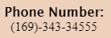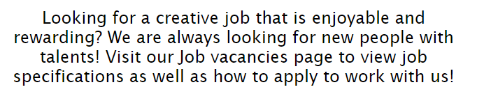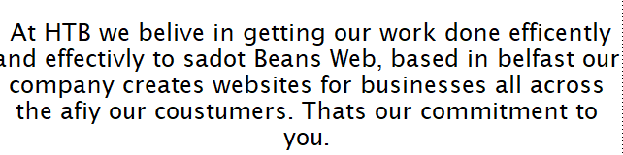In a meeting with my client, he did notice that there were a few mistakes that needed to be fixed, we went through them individually and made sure they were successful fixed.

We noticed that I had spelt the word ‘Hot’ incorrectly.

He noticed that I had put the incorrect phone number as this was another office.

My client wanted this hyperlinked to the Job vacancies page.

My client wanted this hyperlinked to the courses page.

We noticed on my contact us page that there was 2 submit buttons but no reset button, I resolved this by inserting a reset button.

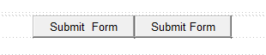

My client also informed me on the features of my website he did enjoy, he liked the layout of each page and how my images and text where positioned, and how all my headings and subheading where the same colour.

My client made me know of how much he liked the amount of white spacing on each page and said it was just enough and how it makes the website look tidy and how it can make it easier to read. He was happy with the colour scheme throughout as it matched their logo colours for Hot Beans Web.

**Code used**

Within my index page I used code from google to create a interactive map where my company was based. I modified this code and embeded it to my index page.

On my index page I used code insterted from shared resouces by C2K , to insert a scrolling marquee. I adapted this code by changing the text and speed it whet when moving across my page.

On my cources page I have used code insterted from shared resources by C2K, to insert my scrolling images. I modified the code to make the images larger in size to fit my screen perfectly.

I went back to my shared resources by C2K and I insterd code for an image gallery, I altered the code by choosing my own images to use. The image gallary is positioned in my Job vacancies page.

On my contact us page I have took code from shared resources by 2Ck and applied to my code to insert my movie. I altered the code to change the name of my movie, the hight and width to fit my page.

|  |  |
| --- | --- |
| How I used the code | Code uses |
| I used this code to create a map that I embeded from google into my index page. I altered the hight and width of the map to fit my page correctly and to suit my client’s requirments. Users can use this map to clearly see where the business is located. | <body>  <div id="mapDiv"></div>  <script nonce="qfCne3aTUygQxdm_poRDgw">  function onEmbedLoad() {  initEmbed([,[[[2,"spotlight1]],["0x48610976ae9edded:0xb74ed38df6f69b16","27  Wingrove Gardens, Belfast BT5 5NA", 54.59338289999999,-5.8818188],0,1], ,11, ,[,"a", ,1, ,0,,1,1],null,null,null,[null,null,null,null,null,2,3,2]],,[12,14,29,30,61,70]]]]],null,["en","uk"],[,"  /maps/api/js/ApplicationService.GetEntityDetails","/maps/embed/upgrade204",null,"/maps/embed/record204"], ,"L9ZlZfiuC9vPwPAP_eqA6AE",null,null,null,[[[1155.804425429938,-5.8818188,54.59338289999999],[0,0,0],null,13.10000038146973],null,0,[  ["0x48610976ae9edded:0xb74ed38df6f69b16","27 Wingrove Gardens, Belfast  BT5 5NA",[54.59338289999999,-5.8818188]],"27 Wingrove Gardens",["Belfast","BT5 5NA"], ,  "Building","27 Wingrove Gardens, Belfast BT5 5NA", ,null,null,null,1,1,null,null,"ChIJ7d2ernYJYUgRFpv29o3TTrc",null,null,  "0ahUKEwi4gsa70uaCAxXbJxAIHX01AB0Q8BcIAigA"]], ,[1]]);  }  function onApiLoad() {  var embed = document.createElement('script');  embed.src = "https://maps.gstatic.com/maps-api-v3/embed/js/55/2/init_embed.js";  document.body.appendChild(embed);  }  </script>  <script src="https://maps.googleapis.com/maps/api/js?client=google-maps  embed&amp;paint_origin=&amp;libraries=geometry,search&amp;v=3.exp&amp;language=en&amp;  region=uk&amp;callback=onApiLoad" nonce="qfCne3aTUygQxdm_poRDgw" async defer></script>  </body> |
| I took this code from shared resources by C2K to create a scrolling marquee across the top of all my pages. I modifed the text size and how fast it travels across the users screen. This alos fits the requirments of my client. | <MARQUEE bgcolor="#A58D7C" direction="right" loop="20" width="100%" class="auto-style14"ww><STRONG>Greetings, Welcome to Hot Beans Web.</STRONG></MARQUEE> |
| I instered this code onto my cources page from shared resouces by C2K to create scrolling images. I chose certain images that sutied the clients requirments and I aslo altered the speed the images went across the users page and the sizing of the images. | <table style="width: 100%; height: 171px">  <tr>  <td style="height: 97px"></td>  </tr><marquee behavior="scroll" direction="left">  <img src="../Pictures/Slide.jpg" width="500" height="400" alt="slide" /><img src="../Pictures/Slide2.jpg" width="500" height="400" alt="Slide2" /><img src="../Pictures/Slide3.jpg" width="500" height="400" alt="Slide3" /><img src="../Pictures/Slide4.jpg" width="500" height="400" alt="Slide4" />  </marquee>  </table> |
| I gatherd this code and insterted a image gallary on to my job vacances page from shared resouces by C2K. I chose certain photots that my client was happy with and insterted them into the picture gallary. | <td width="100%" class="auto-style2">  <img src="../Pictures/Apple.jpg" width="655" height="379" name="photoslider"></td>  <td width="100%"><form method="POST" name="rotater">  <div align="center"><center><p><script language="JavaScript1.1">  var photos=new Array()  var which=0  /*Change the below variables to reference your own images. You may have as many images in the slider as you wish*/  photos[0]="../Pictures/Apple.jpg"  photos[1]="../Pictures/Office1.jpg"  photos[2]="../Pictures/Office2.jpg"  photos[2]="../Pictures/Office4.jpg"  function backward(){  if (which>0){  window.status=''  which--  document.images.photoslider.src=photos[which]  }  }  function forward(){  if (which<photos.length-1){  which++  document.images.photoslider.src=photos[which]  }  else window.status='End of gallery'  }  </script><input type="button" value="&lt;&lt;Back" name="B2"  onClick="backward()"> <input type="button" value="Next&gt;&gt;" name="B1"  onClick="forward()"><br>  <a href="#" onClick="which=1;backward();return false"><small>Start Over</small></a></p>  </center></div>  </form>  </td> |
| Within my contact us page I have instered code which creates my movie, from shared resources By C2K. I have altered this code by choosing what size the moive that my client is happy with. | </table>  </td>  <td style="height: 47px; width: 267px;">  <img alt="j" height="187" src="JOB.png" width="269" /></td>  </tr>  <tr>  <td style="height: 190px; width: 1374px"></td>  <td style="height: 190px; width: 267px;"></td>  </tr>  <tr>  <td style="height: 190px; " colspan="2"><video src="Contact us.mp4" controls style="width: 100%; height: 336px"></video></td>  </tr>  </table> |

**Testing**

**All the testing below was carried out in chrome and Microsoft edge. The corrective actions which don’t work in edge after the table below.**

|  |  |  |  |  |  |  |
| --- | --- | --- | --- | --- | --- | --- |
| Test number | Purpose of test | On page | Test Data | Expected result | Actual Result | Evidence |
| 1 | Test the map | Index.html | Left click hold + drag mouse | Will show where business is located and bring you to goggle maps if clicked | Showed me where business was located and brings me to google maps when clicked |  |
| 2 | Test the scrolling marquee | Template (Applies to all pages) | Scrolls along website | You will view a message scroll across your screen | Showed me the correct message across the screen |  |
| 3 | Test the home page title | Template (Applies to all pages) | Left click | You will be taken to the home page | I was shown the home page |  |
| 4 | Test the courses page title | Template (Applies to all pages) | Left click | You will be taken to the courses page | I was shown the courses page |  |
| 5 | Test the Job vacancies page title | Template (Applies to all pages) | Left click | You will be taken to the job vacancies page | I was shown the job vacancies page |  |
| 6 | Test our team page title | Template (Applies to all pages) | Left click | You will be taken to the our team page | I was shown the our team page |  |
| 7 | Test the Contact us page title | Template (Applies to all pages) | Left click | You will be taken to the contact us page | I was shown the contact us page |  |
| 8 | Test the hyperlink to Facebook | Template (Applies to all pages) | Left click | It will load Facebook | I was taken to Facebook login |  |
| 9 | Test the hyperlink to twitter | Template (Applies to all pages) | Left click | It will load twitter | I was taken to twitter login page |  |
| 10 | Test the hyperlink to Instagram | Template (Applies to all pages) | Left click | It will load Instagram | I was taken to the Instagram login page |  |
| 11 | Test the hyperlink to the contact us page | Template (Applies to all pages) | Left click | It will open the contact page | I was take to the contact page |  |
| 12 | Test scrolling images | Courses.html | Load page | The images will move from the right to the left across the page | I was shown the images sliding across my page |  |
| 13 | Test the hyperlink to code academy | Courses.html | Left click | It will bring you to the correct course | I was brought to the code academy course |  |
| 14 | Test the hyperlink to reed web design | Courses.html | Left click | It will bring you to the correct course | I was brought to the correct Web design course |  |
| 15 | Test the hyperlink to reed web design (different course) | Courses.html | Left click | It will bring you to the correct course | I was brought to the correct Web design course |  |
| 16 | Test the hyperlink to the contact us page | Job vacancies.html | Left click | You will be directed to the contact us page | I was taken to the contact us page |  |
| 17 | Test the next-back buttons for the pictures | Job vacancies.html | Left click both buttons | The images will switch when the buttons are click | I was shown different images as I click next and back |  |
| 18 | Test the text box for first name | Contact us.html | Left click + Type | The text will appear when typed | The text I typed was shown in the box |  |
| 19 | Test the text box for last name | Contact us.html | Left click + Type | The text will appear when typed | The text I typed was shown in the box |  |
| 20 | Test text box for phone number | Contact us.html | Left click + Type | The text will appear when typed | The text I typed was shown in the box |  |
| 21 | Test text box for email address | Contact us.html | Left click + Type | The box will be ticked | The text I typed was shown in the box |  |
| 22 | Test check box for male | Contact us.html | Left click | The box will be ticked | The box was ticked when I click it |  |
| 23 | Test check box for female | Contact us.html | Left click | The box will be ticked | The box was ticked when I click it |  |
| 24 | Test check box for other | Contact us.html | Left click | The box will be ticked | The box was ticked when I click it |  |
| 25 | Test text area for questions | Contact us.html | Left click | The text will appear when typed | The text I typed was shown in the box |  |
| 26 | Test the link for an email | Template (applied to all pages) | Left click | You will be directed to your emails | I was taken to my emails. |  |
| 27 | Test the hyperlink to the courses page | Index.html | Left click | You will be directed to the courses page | I was taken to the courses page |  |
| 28 | Test the hyperlink to the Job vacancies page | Index.htm | Left click | You will be directed to the Job vacancies page | I was taken to the Job vacancies page |  |
| 29 | Test the hyperlink to the Team page | Index.html | Left click | You will be directed to the Team page | I was taken to the job vacances page |  |
| 30 | Test the browser with Microsoft edge.  (Internet explore is not available) | All pages | Open the page in Microsoft edge. | The web pages will open, and all elements will work correctly. | I was taken to the website and all the elements worked. |  |
| 31 | Test the browser with google chrome.  (Internet explore is not available) | All pages | Open the page in google chrome. | The web pages will open, and all elements will work correctly. | I was taken to the website and all the elements worked. |  |

**Gantt Chart**

**Corrective Testing**

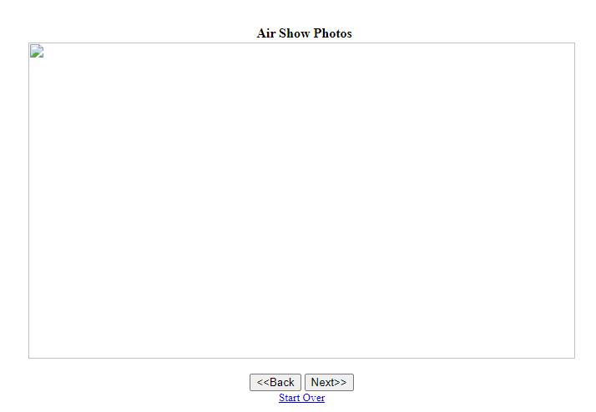

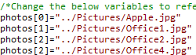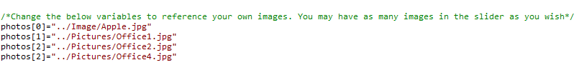

I changed the text to the file name to say pictures to match my file name and it found the picture.

1 of the photos on my Air show wasn’t showing up because my file name is pictures not images.

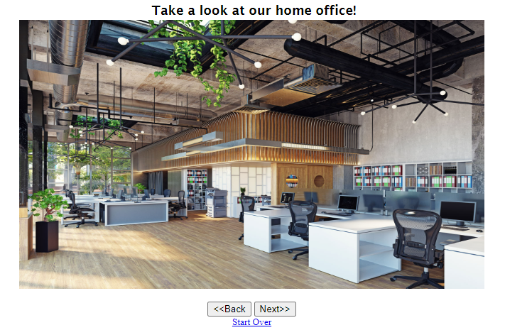

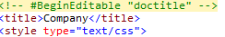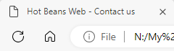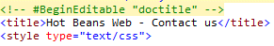

The browser heading on the contact us page was the incorrect name on both web pages.

I changed the script for the title to hot beans web - contact us to match its designated webs page.

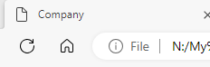

Arial, Helvetica, sans-serif

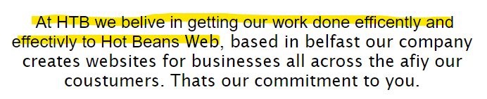

**Bibliography**

<https://www.google.co.uk/>

Date accessed: 27/09/2023.

<https://visme.co/blog/website-color-schemes/>

Date accessed: 29/09/2023.

<https://webflow.com/blog/fonts-for-web-design>

Date accessed: 11/10/2023.

<https://zapier.com/blog/best-free-stock-photos/>

Date accessed: 17/10/2023.

<https://www.ideasonpurpose.com/on/7-qualities-great-website/>

Date accessed: 20/10/2023.

<https://tech.co/website-builders/3-best-ways-make-website>

Date accessed: 24/10/2023.

<https://www.awwwards.com/websites/transitions/>

Date accessed: 09/11/2023.

<https://blog.hubspot.com/marketing/best-website-designs-list>

Date accessed: 13/11/2023.

**Screen shots**

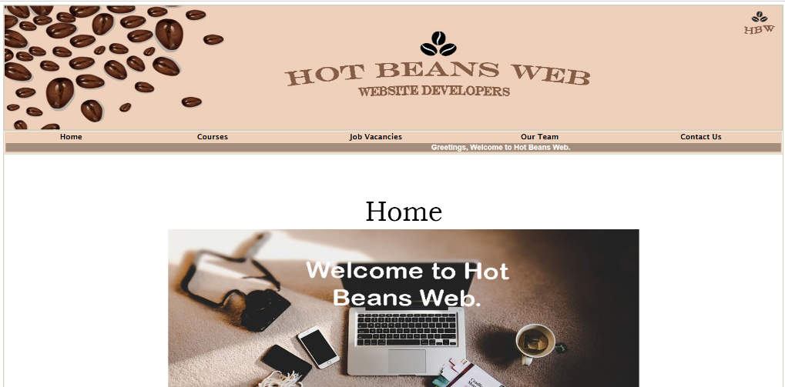

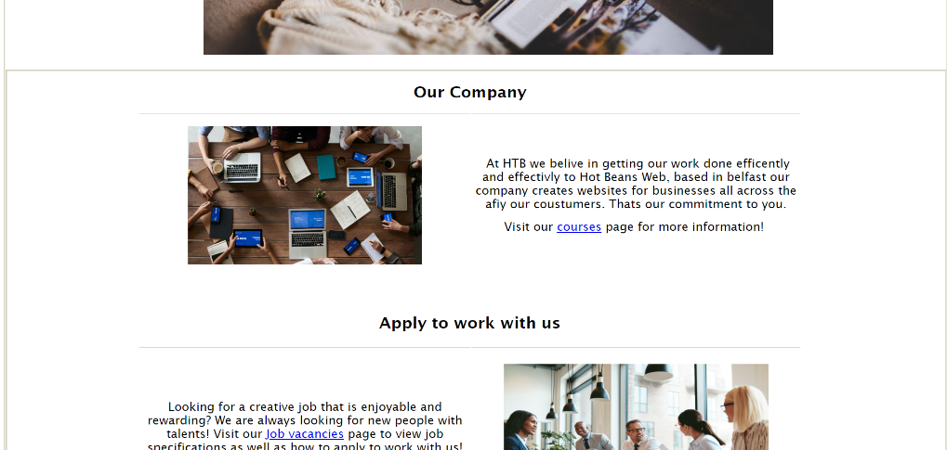

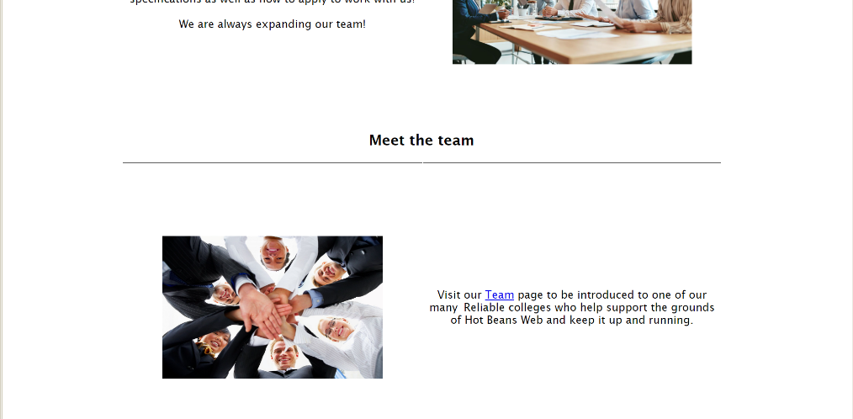

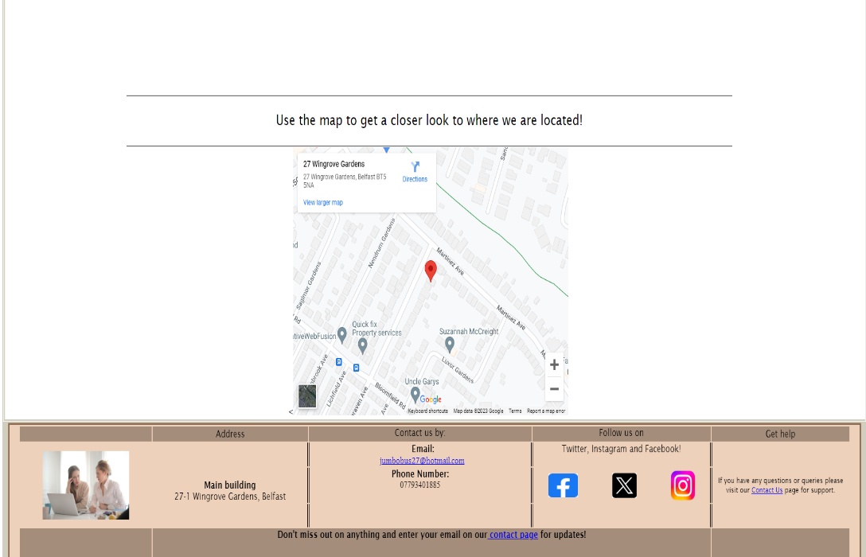

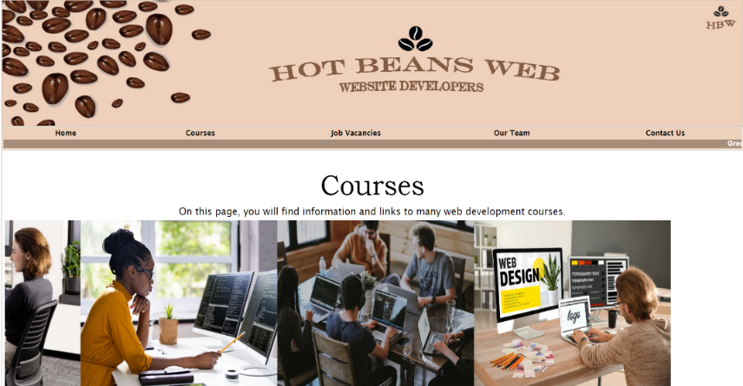

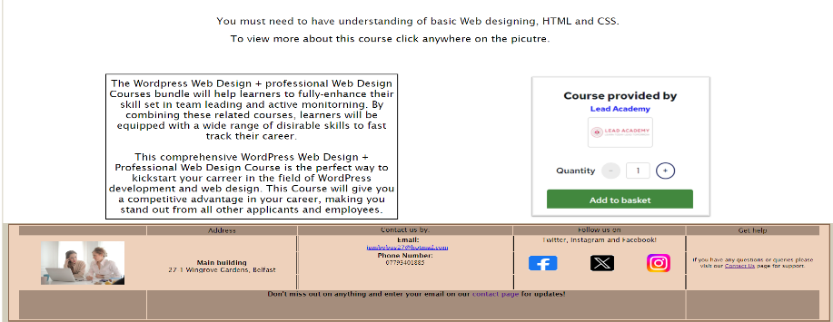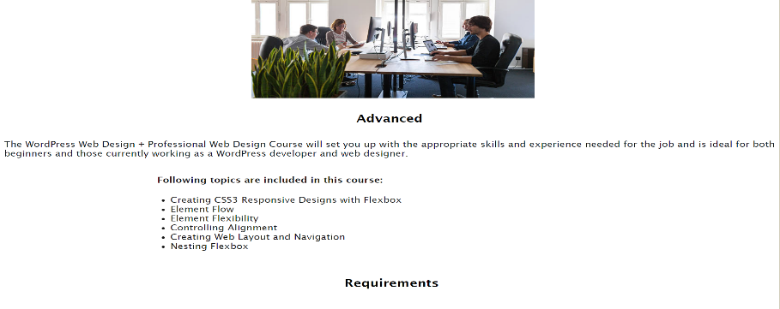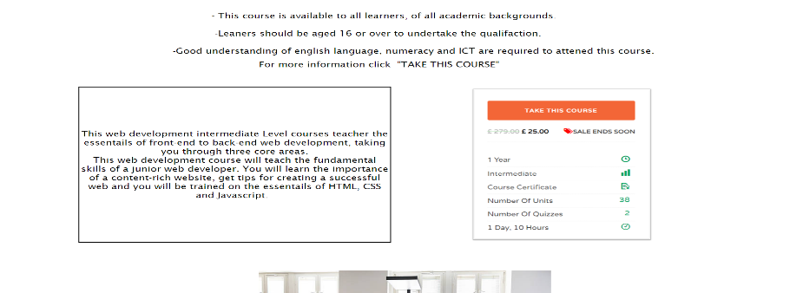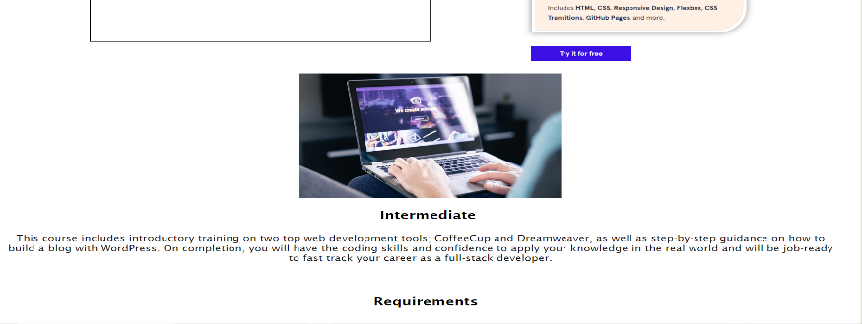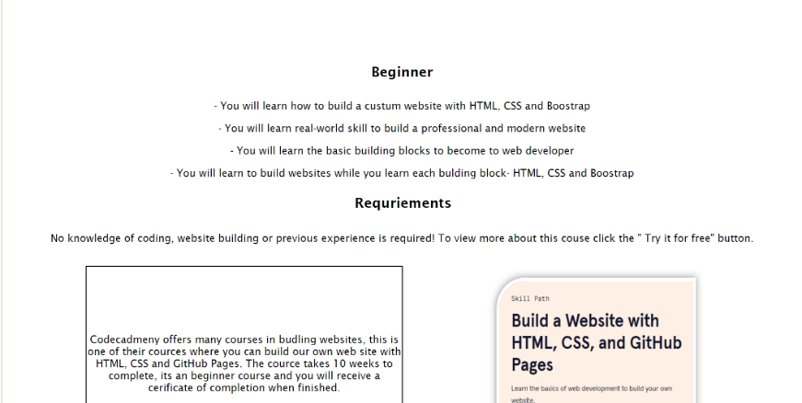

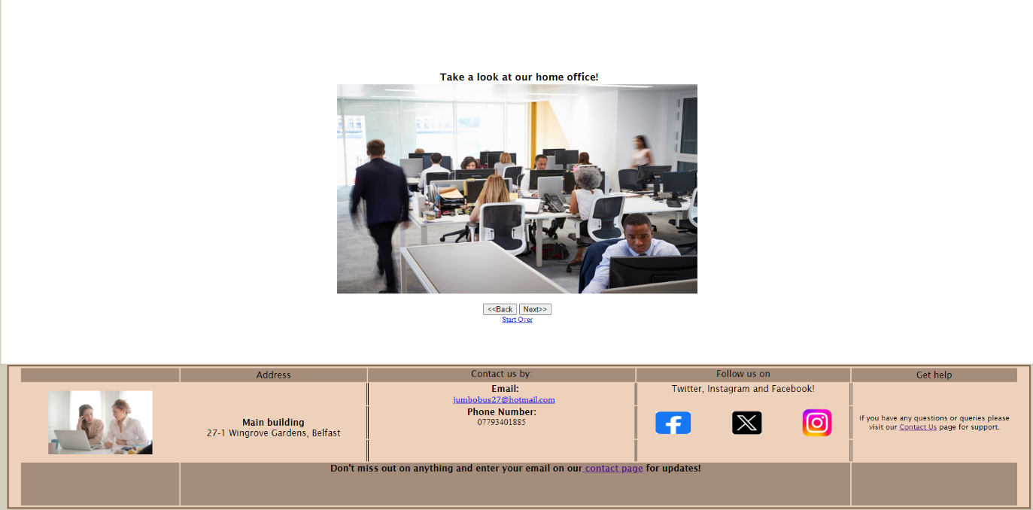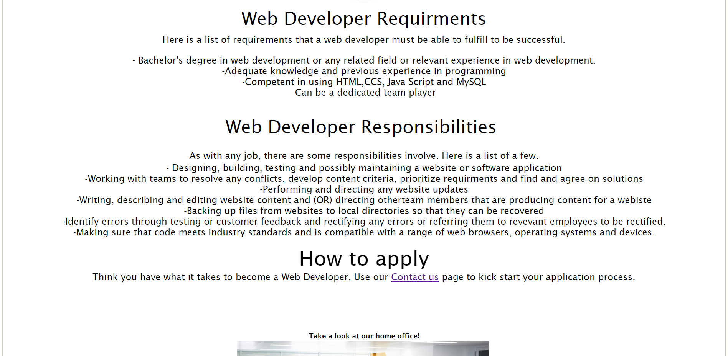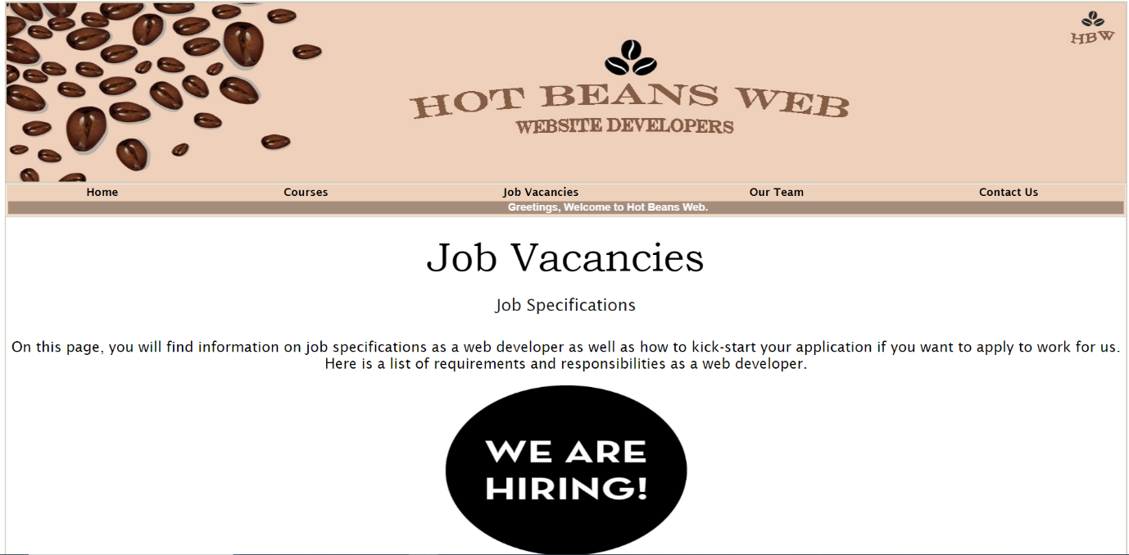

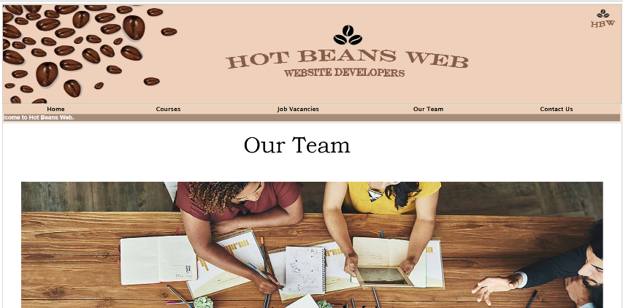

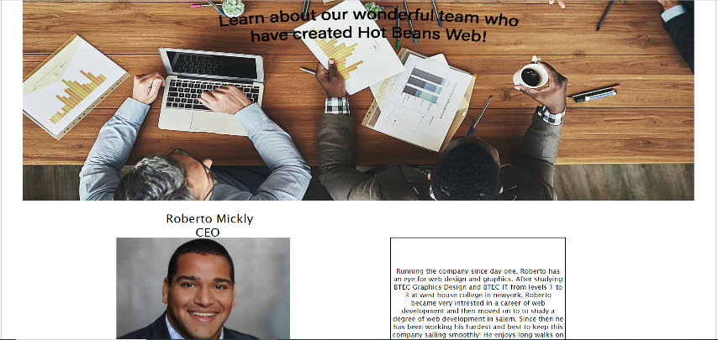

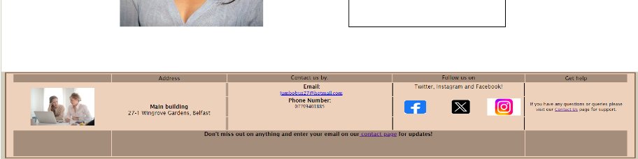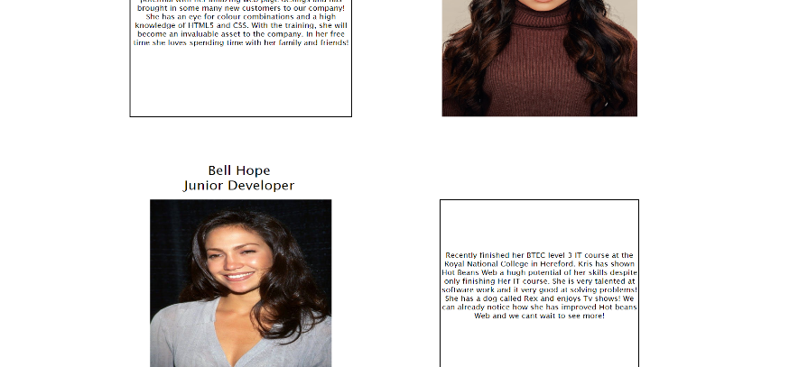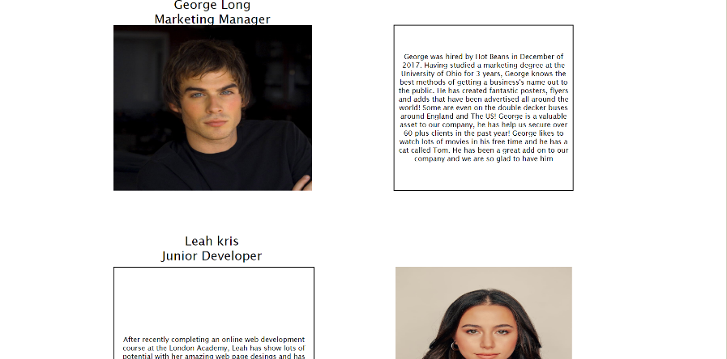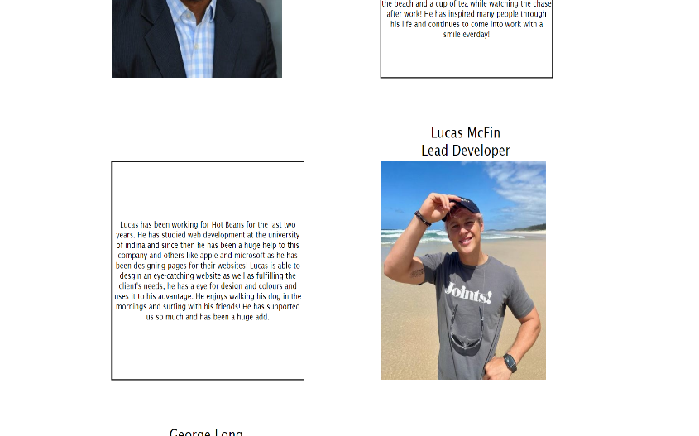

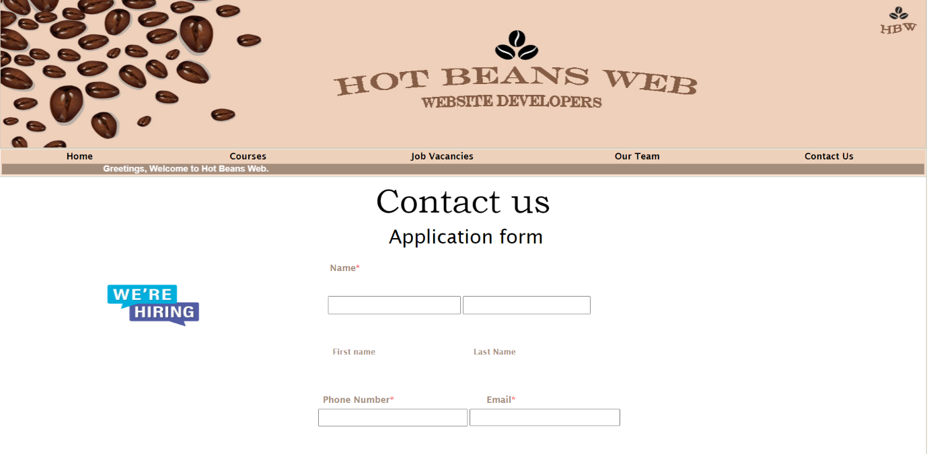

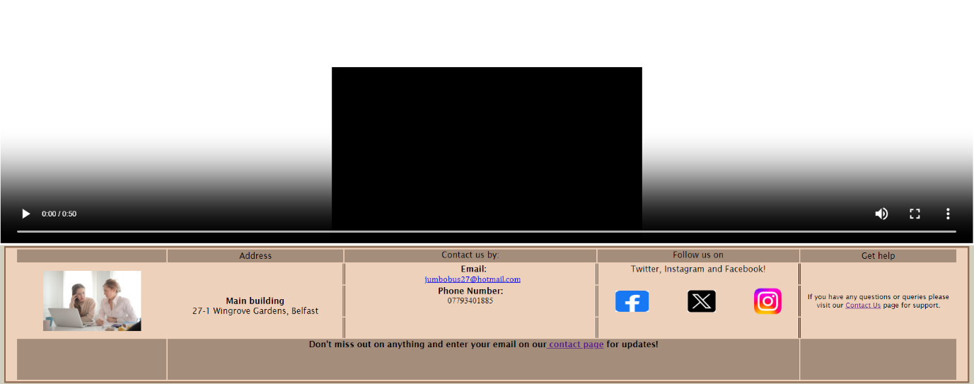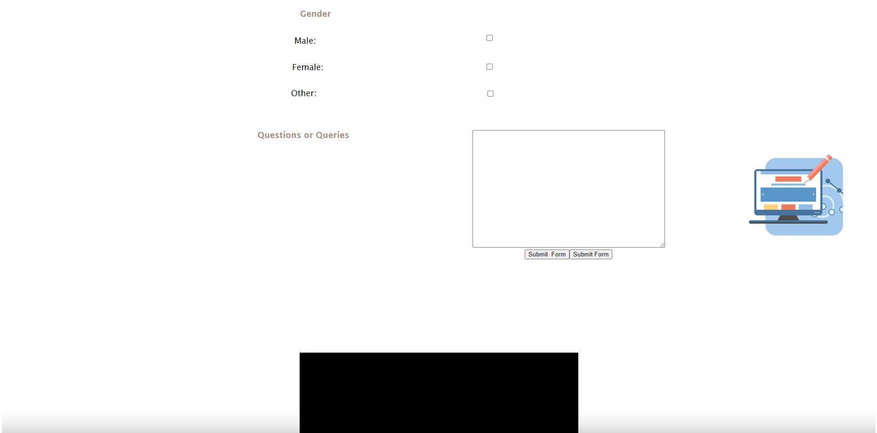

**CSS**

CSS stands for Cascading style sheets.

Legal and Ethical considerations

When creating this website, we needed to consider the legal and ethical considerations involved when designing and developing websites. I had gathered information on the laws that are involved with the website, Hot Beans Web. These laws protect an individual’s intellectual property and ensure their person data is not released, this includes the laws of Copyright, Designs and Patents act 1988 and the Data Protection act 1998.

The Copyright, Designs and Patents Act 1988 protects all original works such as music, art, writing and programming code once it is tangible, which means once it’s in a fixed form like a music album is released or a book is published, these are the property of the person who created them. For my website site I have created a unique banner, logo and movie which is art and images that I own, therefore it is my property so if someone were to utilize any of these it would be considered copyright. It is now accepted that a website like Hot Beans Web.

The Data protection Act 1998 was designed to protect sensitive data held in a database. Therefore, every business that stores personal data about their customers must register and state the data they plan to hold. Under the act, the data subject has several specific rights including the right to compensation for unauthorised disclosure of data, the right to get inaccurate.

**Pre-Optimization**

Pre-optimization involves trying to improve something or make it better, in this case I am attempting to convert my PNG file format to JPG file format.

PNG is short for Portable Network Graphic, a type of raster image file. It’s particularly popular file type with web designers like me, because it can handle graphics with transparent or semi-transparent backgrounds.

PNG is open format, so you can view and edit these files in a huge range of programs without a license because there’s no patent.

However not all

By using the website “PNG to JPG” I was able to transform the files to decrease the over size of the file.





**Post Optimization**





**Evaluation**

My set task from my client was to create a 5-page website that was titled Hot Beans Web. The website had to include an index page, courses page, job vacancies page, existing employee page and a contact us page. With the courses pages having links to separate web design courses.

**Suitability for attendant purpose and audience**

**Index Page**

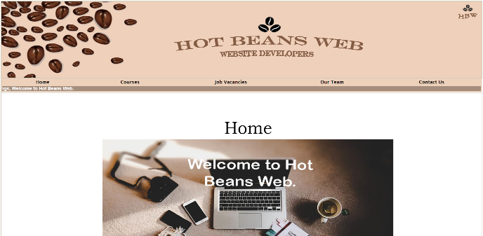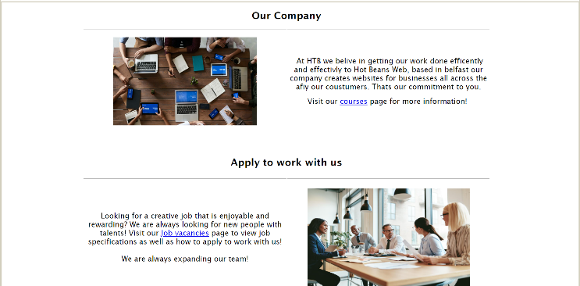In preparation for the developed for Hot Beans Web it was necessary to research, as I viewed similar websites to get an idea of what was expected and I gathered inspiration from it to add to my index page, I wanted this page to be interesting and eye catching as it’s the first page users will view so I included images that were suitable and interactive features as hyperlinked text, google maps and a scrolling marque to engage users yet not overwhelm them. There is an effective amount of white spacing that makes the page look simple and I kept the information brief and straightforward so it’s not over whelming to users.

**Courses**

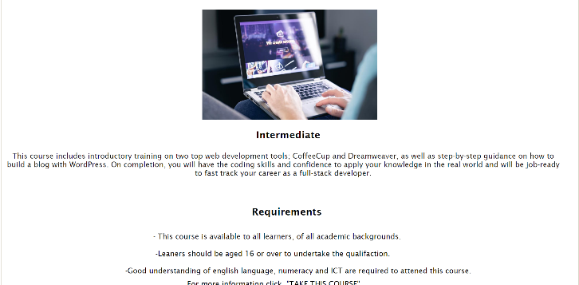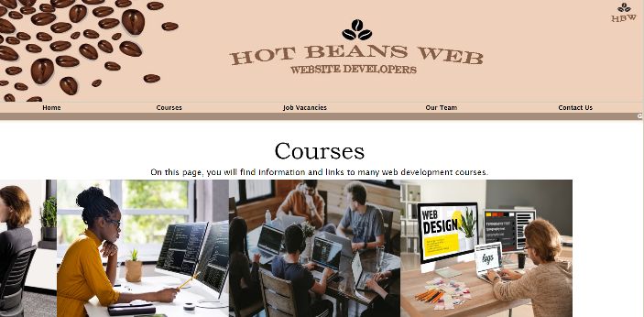In preparation for the developed for Hot Beans Web it was necessary to research, as I viewed similar websites to get an idea of what was expected, and I gathered inspiration from it to add to my Courses page, I added a scrolling image gallery with suitable pictures that relate to the topic of the page, and I believe this was an appropriate choice that adds relevant to the page. This web page includes information about the web design courses chosen by the client and includes hyperlinked images that will redirect the users to that specific course, this add in is very effect yet simple for users to interact with.

**Job vacancies**

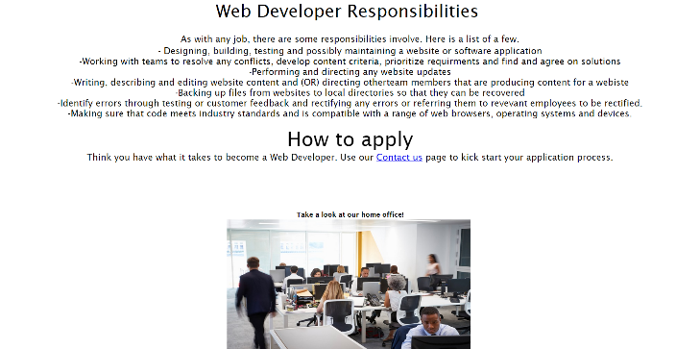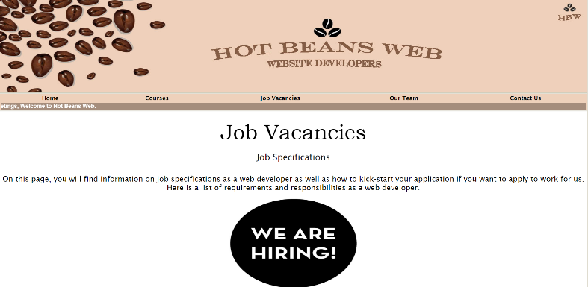In preparation for the developed for Hot Beans Web it was necessary to research, as I viewed similar websites to get an idea of what was expected, and I gathered inspiration from it to add to my Job vacancies page. I inserted a back and forward image gallery with images that relate to this page, I used important information that was necessary like the requirements that the users must be know of if they wish to apply form a job. There is a suitable amount of white spacing and this page is shorter than the rest so its simple for users to understand, I also included hyperlinked texted that would redirect the user to the contact us page if they wanted to apply for a job.

**Our team**

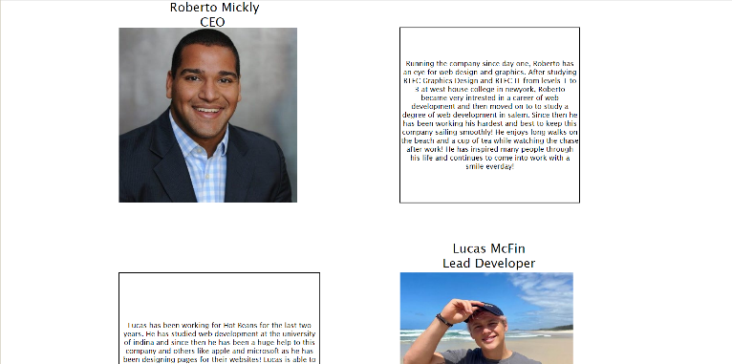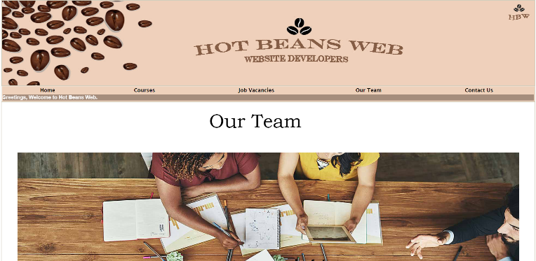In preparation for the developed for Hot Beans Web it was necessary to research, as I viewed similar websites to get an idea of what was expected, and I gathered inspiration from it to add to my Our team page. This page consist of existing members from Hot Beans Web and information about them which was supplied through my client, the page includes relevant information about the individuals in the team which educates the users and keeps them entertained

**Contact us**

In preparation for the developed for Hot Beans Web it was necessary to research, as I viewed similar websites to get an idea of what was expected, and I gathered inspiration from it to add to my contact us page. Within this page is my application form that users can be interactive with and type their details which will be kept private within the company. My own movie is included in this page which has suitable images, text, music and videos which will encourage the users to watch it and be inspired by it to apply for the job. This page 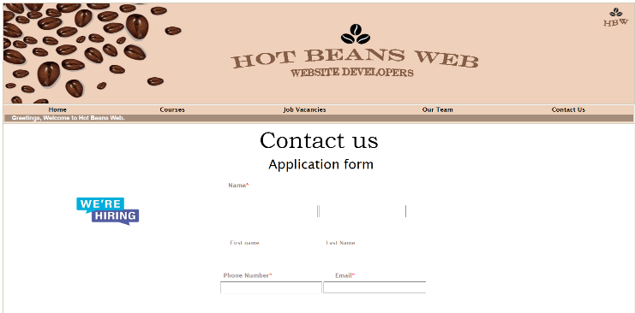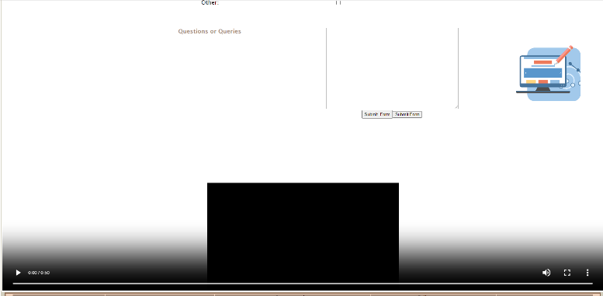includes suitable white spacing and text boxes and tick boxes for applying for a job.

**Quality in comparison with another similar website**

Looking at other websites like the Home Bargains and B&M, the B&M website includes an Image slide show which displays their main products and deals of the week, and this is the first thing users will see when they open the website. I was inspired by this and thought it would be a good way to grab users’ interest to join Hot Beans Web. I used a scrolling image marquee with suitable images which correlate to my website, this is simple yet effect as I felt there was too much white spacing, so this fills that in nicely.

**Suitability against the clients’ requirements**

**Feed back**

My client reviewed my website and gave me some feedback through the google form I created asking questions concerning the websites design and layout and then just the overall site. He replied quickly and gave me lots of helpful information, I was informed that my client didn’t like the size of the font as he gave the explanation that it was too small for users to read so I ended up using a larger font size which I also think was the correct decision. The client gave me positive feedback concerning my movie, he said it was effective, as all the information was relevant, and it also would grab users’ attention to watch it and be influenced by it. My client was happy with the overall colour scheme, font type, layout, white spacing, use of interactive activity, images and hyperlinks.

**Strengths, weakness and improvements**

**Strengths**

**●** When creating each page on my website I made sure that all fonts, colour and sizes where all the same throughout the application

**●** I made sure that each page has a similar colour palette, making it more official and professional

**●** I have used relevant and informative information on each page of the application that is needed for the end user.

**●** Each page is set out formally and it’s easy to understand and read

**●** My template I had made was very helpful and I applied it to each page, it gave a good foundation lay out for the rest of my pages on the website

**Weaknesses**

**●** The pictures on my index page and a bit to spaced out and I struggled to get them all the same size

**●** My pictures gallery on my job vacancies page, some are blurry, and it took me a while to get to them all work.

**●** Some of my pages could have had more information but I struggled finding the right type of info.

**●** I struggled to make a base layout for my website, and I feel like I could have done better.

**●** To much white spacing on pages or there is to little on other pages

**Improvements**

**●** I feel like I sound of spent more time fixing the issues on my website.

**●** Include more information on some of the webpages.

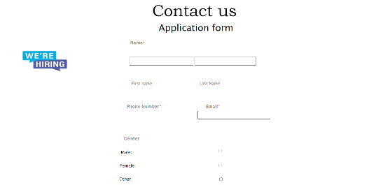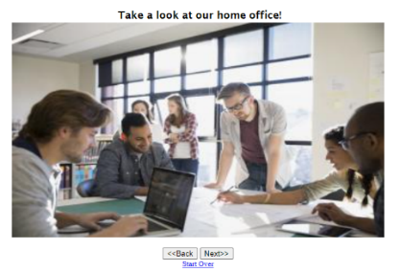**●** Spend more time looking over fonts and make sure they are all the same size



